Introduction

It was difficult to understand what this chapter is about. The first paragraph should provide the reader what to expect. Its not until I-Corps was defined towards the end this reviewer understands. Maybe the introductory paragraph of that section can move up and then explain how the mechanism on the ship was used to accomplish the goal. Just the first paragraph for this.

Innovation can be described as the actions necessary to bring discovery and invention to the masses. The team, BRIDGING THE FUTURE, implies, the end goal is the make a better future by transitioning new thoughts, discoveries, and ideas in products and services that benefit all, regardless of race, ethnicity or any other categorical selection.
Technology is an indispensable aspect of our day-to-day lives. The obvious are computers, laptops, mobile phones, portable devices and the Internet or Things (IoT). Although not obvious, other innovations and emerging technologies in the biomedical space are indispensable part of an individual well-beling. These technologies is part of the system to improve global quality of life. In addition to countless examples of entrepreneurial innovations, there are also other innovations funded by the people of countries such as the National Institute of Health in the USA. The translation of these innovations into the market and commercial success often meets with failure due to a lack of understanding of the true customer, product fit.
After the devastating hurricanes in 2017, the University of Central Florida (UCF) Innovation Corps (I-Corps) (define UCF) team decided to leverage the Lean Startup methodology to assist several teams with in the most impacted areas, including the U.S. Virgin Islands, parts of Florida, and the Bahamas. Using I-Corps methodologies and curricula had the potential to assist with disaster recovery efforts through bringing innovations into the commercial space, and the novel innovations may also prove successful in future prevention and recovery by leveraging innovative methods. A full description of I-corps is provided at the end of this chapter.

Upon meeting Dr. Desiree Cox at a medical innovation conference shortly after the hurricanes, several UCF I-Corp team members proposed a joint collaboration among U.S. islands, Florida, and the Bahamas. We reviewed the Nation Science Foundation (NSF) rules and discovered that additional outside sponsorship would be required to cover international travel and any costs incurred by a non-US citizen. Undeterred, our team decided to pilot an I-Corps cruise between Florida and the Bahamas that would allow our team members to collaborate internationally, and invite fellow researchers from the U.S. Virgin Islands and Puerto Rico interested in health and education redevelopment. It would also allow us to leverage partnerships with Doctors Hospital (what is this?), and our US partners in Lake Nona Medical City and UCF, to produce a unique international experience.
We proceeded to include the first few sessions of the I-Corps site curriculum (this curriculum has to be cited) as well as a hackathon-style collaborative work session. The hackathon-style session focused on disaster recovery and disaster kit planning through commercializing future innovations, which followed the Hacking For Defense (H4D) Mission Model Canvas and the Customer Discovery process while in the Bahamas and when returning to the U.S. CAN YOU REVISE THIS PARAGRAPH TO MAKE IT APPLICABLE TO OTHER COUNTRIES
Any concerns that the team members would be distracted by the cruise ship environment were quickly dispelled. We made use of a conference room on the ship and the fact that cell phones did not have reception and the cost of internet was prohibitive, kept the teams focused and attentive. The teams were engaged with each other and supportive of each other’s efforts.
The housing mechanism in the ship was part of the team effort. We placed two teammates per room and shared rooms for instructors. All shared meals to develop a camaraderie. The meetings were held on the ship or at the hospital conference room. One half-day was devoted to the cruise ships’ island retreat, which seemed to bolster the shared experience and comraderie.
The overall experience was unique with the teams showing a more cohesive and accountability to each other as well as the overall cohort than a typical cohort (clarify). The mechanism during 4 weeks showed a noticeable difference than the traditional class with a 4-day immersive experience.
The goal of the lean methods based curriculum such as I-corps was to get individuals to understand and utilize the scientific method to evaluate their idea discovery, or invention. Team must convert all their beliefs into a set of untested hypothesis. They must do discovery and validation of their value proposition, customers, channels and more and get an in depth understanding of the intended problems.
This particular cohort and the UCF instructors benefited greatly from the very different curriculum and teaching style of Dr. Desiree Cox. Tom O’Neal and David Metcalf have engineering and computer science backgrounds. They focused on lean methodology delivered in a Socratic manner to expose students to a Silicon Valley type of engagement.
Dr Cox, however, gave the cohort an overnight assignment consisting of two question:
- What is the meaning of life
- Why work
The instructors were also given the assignment. The next day was spent openly discussing and answering these questions. The answers were remarkably candid and masterfully steered by Dr Cox to get them to understand true life – work balance focusing on the participants. Her design thinking approach incorporates life into the design of one’s life.
The feedback received from the participants was the best we have received from any cohort. The Bahamian students made comments that it was inspirational and one stated that it was life-changing. It was rewarding as instructors to make such a connection with participants with the feeling of accomplishing positive input into the participants and the knowledge that they will utilize the information going forward.
I believe this type of curriculum, delivered in a similar manner, is needed in the regenerative health field. It is the bridge to the future. It takes discovery and effectively moves it to the marketplace. It does it in a way the uses the same scientific method as in the laboratory where many of these discoveries originate. It benefits the commercialization process necessary to get these discoveries out of the laboratory and into the commercial market place to benefit all while creating opportunities. Overall, the process benefits the larger/global society.
I-Corps
I-Corps, developed by the National Science Foundation (NSF) and expanded to other organization including the NIH, was developed to increase the efficiency of the translational aspect of research. The program was quickly recognized as an effective tool. It was launched at the University of Central Florida (UCF) in January 2015, and was the first I-Corps program in the state of Florida. UCF’s I-Corps program has demonstrated its ability to reduce the gap between theoretical and practical innovative ideas.
Unlike traditional lecture-based courses, the I-Corps program is a flipped, practical, hands-on learning laboratory that helps teams live and engage the entrepreneurial experience through a systematic process of structured activities and mentorship by industry experts. Each participating team is required to perform customer outreach, in which they talk to customers, partners, and competitors to determine the feasibility of their current business models and assumptions, and to experience the chaos and uncertainty of how a startup actually works under pressure
Under the NIH version of the I-Corps program, the NIH and CDC foster the development of early-stage biomedical technologies, focus on teaching researchers how to gain a clearer understanding of the value of their inventions in the marketplace, and ultimately how to advance their technologies from the research lab into the commercial world. Their program is designed to complement activities within the scope of the parent SBIR Phase I (R43) or STTR Phase I (R41) grant or the Phase I portion of an SBIR/STTR Fast-Track grant (R44/R42, respectively), to help accelerate the commercialization of new products and services derived from NIH- and CDC-funded technical feasibility studies.
The NIH I-Corps program is supported through administrative supplement awards to active NIH or CDC SBIR and STTR Phase I grantees. Administrative supplement awards are intended only to support travel and other costs associated with the training program. A cohort (up to 24 teams per cohort) will be selected to participate in the I-Corps at NIH program, which is expected to last approximately eight weeks
Instructors for the course are certified in lean methods and instruction and each instructor is trained in delivering the I-Corps curriculum. It is anticipated that the feedback and learning gained during the I-Corps program will help inform future SBIR/STTR projects and commercialization strategies.
NSF I-Corps Sites and Nodes
As shown in the following illustration, awarded I-Corps sites and nodes are centered around either established or emerging high-tech, entrepreneurial-based regions, which includes Central Florida along the Interstate 4 (I4) corridor between the Metro Orlando region and Tampa Bay:

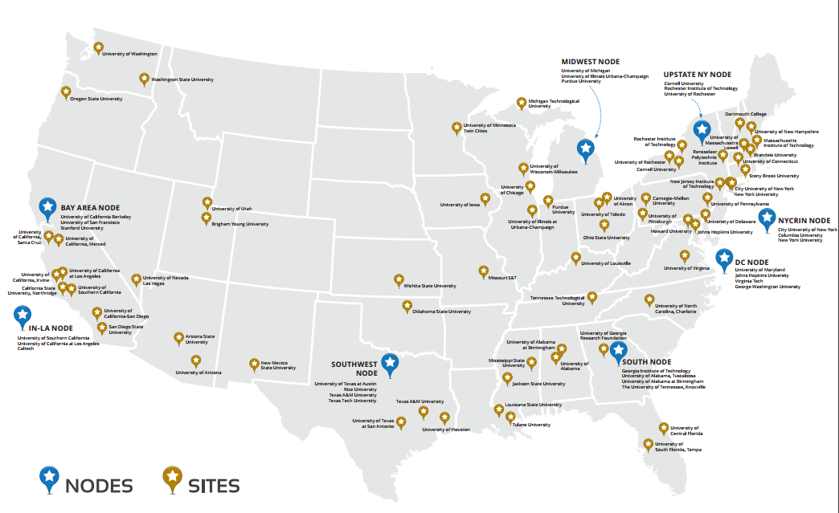
Figure 1: National I-Corps Sites and Nodes

I-Corps Site Program Process
I-Corps offers proven curricula, tools, and methodologies such as the BMC and Lean Launchpad™ (LLP) to help entrepreneurs determine the feasibility of their potential venture. Through the Customer Discovery process, I-Corps requires team members to reach outside of the academic environment to speak with potential customers, and identify the impact their innovation may have within the market or on a specific industry. Using the BMC, the assumptions of the initial business models are then updated weekly based on the gathered information to help entrepreneurs make informed decisions based on actual data
Selected teams participate in a five-week, Socratic-delivered curriculum that takes them through the first four of nine sections of the Business Model Canvas (BMC) using a flipped classroom approach. Participants are expected to commit at least three to five hours per person per week to perform market research, customer discovery, and other commercialization-focused activities. It is important to establish that teams are interested in gaining new knowledge from I-Corps rather than focusing on receiving the $2,600 I-Corps grant. Teams conduct interviews and report their findings on a weekly basis. Instructors provide materials in class and use on-line educational delivery methods.

I-Corps Teams
Teams are generally comprised of three people: Entrepreneurial Lead (EL), Principal Investigator (PI) and Industry / I-Corps Mentor.

Entrepreneurial Lead (EL)
The entrepreneurial lead (EL), typically a postdoctoral researcher, graduate student, undergraduate, or other student, possesses relevant technical knowledge and a deep commitment to investigate the commercial landscape surrounding the innovation. The entrepreneurial lead should also be prepared to support the transition of the technology, should the I-Corps project demonstrate a level of readiness appropriate to leave the academic institution.

Principal Investigator (PI)
The principal investigator (PI) serves as the technical lead and project manager, who deeply understands the science and limitations of the technology. This role is typically assigned to a faculty member, Ph.D. or researcher.

Industry / I-Corps Mentor
This team member is typically a seasoned entrepreneur or business executive with more than 10 years of industry experience. The Mentor guides the team forward, serves as a sounding board, and assists the team in finding relevant research and individuals to interview. The mentor interprets results of the “tests” and offers honest opinions on feedback received. UCF I-Corps will provides each team with a mentor should they require one prior to beginning the program.

UCF I-Corps Site
In 2013, UCF became one of the original 16 NSF I-Corps sites and the first in Florida, affording the university with the opportunity to further enhance its entrepreneurial offerings and infuse the LLP methodology, curriculum, and approach as the de facto standard throughout the university and the Central Florida entrepreneurial ecosystem. Over the past five years, UCF has trained more than 150 entrepreneurial teams of faculty and student researchers. This includes a dedicated life sciences cohort conducted at and in collaboration with Florida Hospital Orlando, and several pilot programs conducted at and with industry partners such as the Boeing Corporation, Siemens U.S.A, and the Walt Disney Corporation. Further, diversity and inclusivity are at the core of UCF’s I-Corps program; of the more than 400 people who have participated in UCF I-Corps , 34.3% have been under-represented minorities.
As of this writing, the UCF I-Corps site has 130 teams that took the UCF I-Corps course from January 2015 to November 2018 and found that 57% of the teams engaged in a creating a startup as shown in Figure 1.
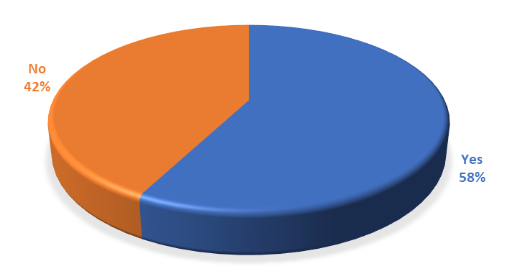
Figure 1: I-Corps Teams Engaging in a Startup (Jan 2015 – Nov 2018)
The 130 teams had a high blend of sectors that included healthcare, banking services and e-commerce, energy and environment, gaming, recreation and sports, education and research, nanotechnology, software and simulation tools, sports, and services and entertainment. The percentage of teams within each sector in shown in Figure 2. Examples of teams’ missions within each sector include:
- Healthcare: Heath data monitoring and storage, health training and awareness and development of innovative tests for various health issues and conditions.
- Software/Simulation Tools/Search: Flight simulator, Human task simulation tool and cloud services
- Banking Services/e-commerce: financial and credit card management services, online purchases and brick and mortar stores services.
- Energy/Environment: thermoelectric devices, wires to manage energy and solar panels
- Gaming/Recreation/Sports: modern game engine technology and engaging global community of fans in real time.
- Education/STEM/Research: interactive learning tools and instructional content and strategies
- Nano Technology/Materials: synthesizing quantum dots and low-cost manufacturing.
- Services/Entertainment: applications to provides access to nightlife and events, connect individuals in the music industry, connect Connects individuals to charitable causes and services to help people moving to unfamiliar areas know the neighborhood.

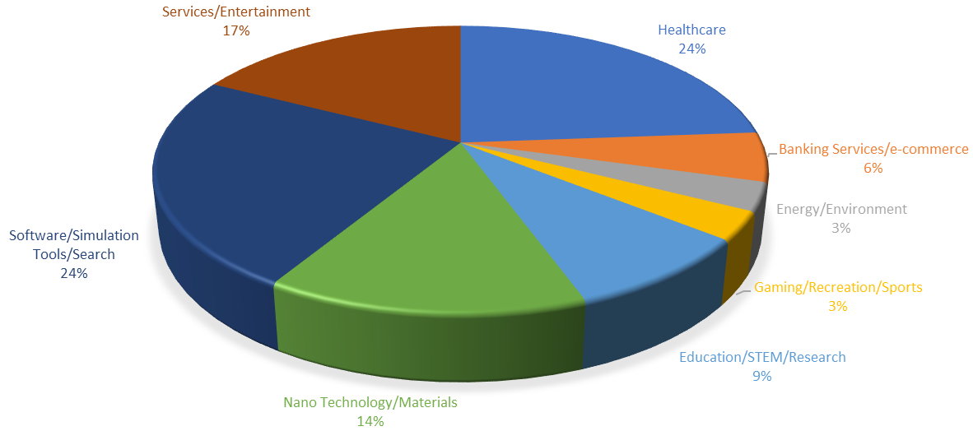
Figure 2: I-Corps Teams Sectors (Jan 2015 – Nov 2018)
I-Corps Nodes
The NSF Innovation Corps (I-Corps) Nodes are designed to support regional needs for innovation education, infrastructure and research. The Nodes will work cooperatively to build, utilize and sustain a national innovation ecosystem that further enhances the development of technologies, products and processes that benefit society.
The interconnected nodes of this network may be diverse in research areas, resources, tools, programs, capabilities and in geographic locations, while the network will have the flexibility to grow or reconfigure as needs arise.
I-Corps Nodes foster understanding on how to:
- Identify, develop and support promising ideas that can generate value;
- Create and implement tools and resources that enhance our nation's innovation capacity;
- Gather, analyze, evaluate and utilize the data and insight resulting from the experiences of the I-Corps Teams, and;
- Share and leverage effective innovation practices on a national scale to improve the quality of life for the American public.
Currently, there are nine I-Corps Nodes nationwide:
- Bay Area Regional I-Corps Node(BA)
- DC/MD/VA Regional I-Corps Node (DMV)
- I-Corps South Node (SOUTH)
- Innovation Node-Los Angeles (IN-LA)
- Midwest I-Corps Node (MWIN)
- New England Regional Innovation Node (NE I-Corps)
- New York City Regional Innovation Node (NYCRIN)
- Southwest Innovation Corps (SWICORPS)
- UNY I-Corps Node (UNY)
The nodes programs are longer than a sites program, cover the entire business model canvas and provide $50,000 per team. Many of the site program graduates apply for the nodes program.
Conclusion
Training students in entrepreneurship has a significant and positive impact on the business world, and it a critical component for regional economic stability and growth, and continued competitiveness in the knowledge-based global marketplace. Entrepreneurial education is varied, from basic knowledge through to in-depth, BMC and customer-focused programs such as NSF I-Corps; regardless of the program and its complexity, it has a strong impact on the participants of these programs, and prepares them to meet the challenges of the entrepreneurial process and make a true impact on the economy. It helps students gain the resources, knowledge, confidence, and skills to enter an industry and make their creative ideas into something tangible. Training also teaches students more about the entrepreneurship industry and helps them ascertain the skills to create successful businesses and, in turn, stimulate the economy.

Based on the success of the Bahamas program, further collaborative efforts including a follow-up visit to speak at the Bahamas Future Health Innovation Summit with Drs. O’Neal and Cox, and many other world renowned experts, such as Robin Smith, Peter Diamondis, and Aubrey DeGray, among others. Most recently, the team has also agreed to collaborate on other speeches, conferences, and written works such as this book. We anticipate further on-going collaboration that may be beneficial to our students, entrepreneurs and innovation programs in Florida, the Bahamas and throughout the Caribbean. The following information provides a brief summary of the goals and itinerary of the world’s first NSF I-Corps cruise. [Note to editor: Include the narrative from the brochure as additional insight for details on the program. Perhaps include pictures of the group from the cruise or the I-Corps event in action.]

https://venturewell.org/I-Corps/nodes-and-sites/

