The 2023 HEALinc Future Health Innovation Summit | Special Invitation

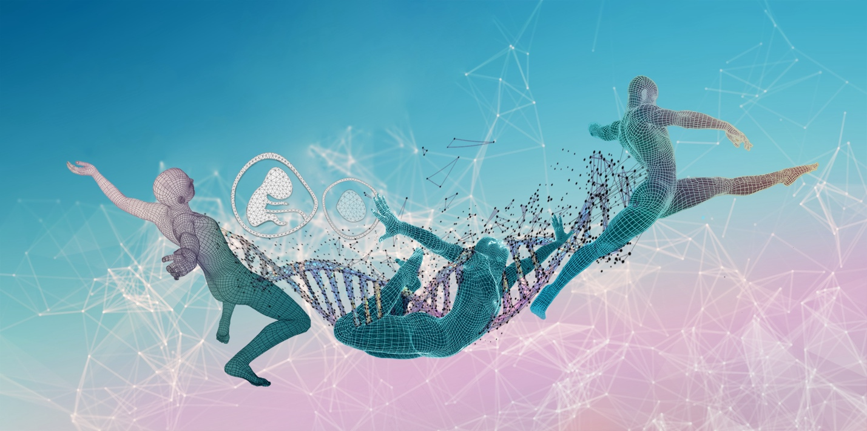

April 17th – 19th, 2023 | Atlantis Resort | Paradise Island, The Bahamas.
https://www.healincsummit.com

You have been cordially invited to attend the annual 2023 HEALinc Future Health Innovation Summit, April 17th-19th, 2023, at the Atlantis Resort on Paradise Island, The Bahamas.

Did you know that aging is a disease? Get firsthand information on how to program your brain and body with youthful signals so you can live better and longer. Learn from the world’s top scientists, doctors and innovators. Take control of your own health and take charge of your future. Find out how to access cutting-edge longevity and regenerative health technologies.

CLICK HERE TO REGISTER NOW

