(FRONT/COVER PAGE)

The 2023 HEALinc Future Health Innovation Summit

Quality of Life and Access to Longevity and Regenerative Health Technologies, Now!

April 17th – 19th, 2023
Atlantis Resort, Paradise Island, The Bahamas
https://www.healincsummit.com

[Insert Signature Image Here]

(PDF BEGINS HERE)

About The HEALinc Future Health Innovation Summit

[Insert Stock Image 2]

The future of health is all about healthy longevity, quality of life, and safe regenerative therapies. But how do we access these benefits under the weight of suppressive bureaucracies, outdated thinking styles and systems, and unmet global health needs for the majority of the world’s population?

Founded by Dr. Desirée Cox (MD, MPhil, PhD), The HEALinc Future Health Innovation Summit is a global organization that partners with top healthcare innovators and industry leaders to remove barriers to self-efficacy, enhanced personhood, and overall human health. With a unique cross-disciplinary and cross-generational model, HEALinc’s mission is to accelerate affordable access to safe and effective regenerative medicines, cultivate a global network of protected ecosystems for R&D and translational medicine, and advance “self-care is healthcare” as the emerging mandate for global personal wellness around the world.

The 2023 HEALinc Summit

[Insert Image 2]

The theme of the 2023 HEALinc Future Health Innovation Summit (which runs from April 17th through April 19th, 2023) revolves around “Quality of Life and Access to Longevity and Regenerative Health Technologies, Now!”

The 2023 Summit will elevate the educational and clinical translational knowledge about regenerative health and longevity for in-person attendees from regions all over the world, including Europe, the US, Canada, The Caribbean and Latin America, Africa and Asia. The conference will trace recent developments and address gaps in the field of longevity and regenerative medicine to move towards a more holistic approach to human health.

[Insert Image 1]

The HEALinc Summit brings together esteemed cross-disciplinary experts in a Summit designed to break through the silos between sciences, clinic medicine, health policy and the broader healing arts. Our list of esteemed speakers/sponsors and delegates include international scientists, clinicians, healthcare providers, investors, policy makers, commercial entities, and pharmaceutical companies (for more details, visit https://www.healincsummit.com).

The 2023 Summit will be attended by 350-400+ in-person attendees and 1,000+ virtual attendees. This year will feature 40+ speakers whose topics range from the science of healthy longevity and cultivating the next generation of regenerative medicine to space and longevity, female fertility and longevity, research on new regenerative health technologies such as psychedelics and CBD, advanced meditation techniques for mitigating trauma and stress, and other integrative treatment approaches for regenerative medicine.
The 2023 HEALinc Summit: Three Unique Selling Points (USPs)

[Insert Stock Image 3]
- Integrative Summit Design: The Summit leverages a unique educational networking opportunity for the world’s top innovators, scientists, inventors, entrepreneurs, thought leaders and healthcare providers to connect and learn more about the latest cutting-edge technologies in longevity and regenerative health.

[Insert Atlantis Image]

- Leveraging Geographical Location for Accelerated Patient Access to Regenerative and Longevity Technologies: The 2023 HEALinc Summit is going to be the most notable since the inaugural event in 2018, as the Summit will be taking place in The Bahamas during the country’s 50th year of independence. Furthermore, The Bahamas has a legal regulatory framework for safe access to stem cells, regenerative medicines and other future health technologies for patients. The Summit is the perfect place for medical tourism-based partnerships between investors, scientists and commercial entities.

[Insert BTF Image]

- Bridging-The-Future Youth STEM Program: HEALinc Bridging-The-Future runs as a parallel program throughout the main conference and has remained one of the most unique selling points of the Summit since the inaugural event in 2018. HEALinc BTF focuses on Networking, Exposure, Training and Opportunity for the top 100 STEM students in the Bahamas and the Caribbean (ages 10-17). For certain key sessions, these future STEM rockstars are immersed in the main adult Summit where they can interact with conference delegates and posit questions to Summit Speakers during the Q&A and panel sessions.

What is The HEALinc?

[Insert Stock Image 4]

The HEALinc (https://www.healincsummit.com) is a global organization founded by Dr. Desirée Cox, MD, MPhil, PhD, a Rhodes Scholar and key architect of an innovative, ethical model for accelerating global access to regenerative medicines. The HEALinc provides a platform to bring together a cross-disciplinary and cross-generational cadre of top-tier scientists, healthcare providers, investors, commercial entities, and industry leaders to 1) co-create a coherent, unified future health narrative of longevity and rejuvenation; and b) ensure optimal cross-pollination between our education and R&D programs. HEALinc partners with innovators, industry leaders and benefactors to remove barriers to self-efficacy and enhanced personhood for the benefit of human health and the planet. Our approach is 3-pronged:

[Insert Image 3]

- Convenings that Connect People, Ideas and Opportunities: Our unique cross-disciplinary and cross-generational HEALinc Future Health Summits in 2018 and 2019 amplified connectivity and global networks in stem cell, regenerative medicine, mind-body and personal wellness spaces. Upgrading to the hybrid, intimate, in-person HEALinc360 conclaves (advanced by our 360 online platform) will enhance our global impact.

[Insert Stock Image 5]

- Ecosystem for Accelerated Access to Advanced Technologies: For close to a decade, HEALinc360 Founder Dr. Desirée Cox has been the leader for an ethical system for accelerated access to emerging regenerative medicines and advanced longevity technologies. The prototype ecosystem in The Bahamas is set to be upscaled and networked globally in 2023.

[Insert Image 4]

- Unleashing the Collective Genius of People Everywhere: Unlocking the collective intelligence about proven resilience, regenerative health and longevity practices from diverse populations inspires innovation and empowers individuals everywhere to take control of their own health and wellness prior to illness, throughout illness, and into healing. Our Bridging-to-the Future program for integrating young STEM students (ages 10-17) into our HEALinc Summits and conclaves takes inclusivity to another level.

For more information on The HEALinc and past HEALinc Summits, visit our website: https://healincsummit.com/about/

Our Target Audience

The HEALinc Future Health Innovation Summit offers a unique networking opportunity for top luminaries, investors, scientists, policy makers, thought leaders and acclaimed speakers, both internationally and within the Bahamas. Our Summits leverage the commercial advantage of a crucible for global access to safe, US-manufactured regenerative medicines and advanced longevity technologies, and provide an educational space for connecting a global network of innovators, healthcare providers, and patients. Our target audience falls within three broad categories:

[Insert Stock Image 6]

- Scientists and Innovators will discover how to increase global access to safe regenerative medicines and longevity technologies not available in the US to patients with unmet needs.

[Insert Stock Image 1]

- Entrepreneurs and Investors will have the opportunity to form partnerships with local healthcare professionals to get ahead and create pathways to commercialization of cutting-edge health technologies.

[Insert Stock Image 7]

- Healthcare Providers (International and/or Local Nurses and Doctors) will learn how to better help their patients improve quality of life using the latest future health technologies, many of which are being made available in the Bahamas through US companies operating in the translational medicine space. MDs will receive 2 CME credits for attending the Summit.

2023 Summit Attendance and Attendees

[Insert Image 5]

HEALinc stands for, believes in, and champions the future of health: healthy longevity, sustained quality of life, and regenerative therapies with no undesirable side effects. Attendees of the 2023 Summit can expect to have their educational knowledge of regenerative health and longevity elevated, as we aim to trace recent developments and address gaps in the field to move towards a more holistic approach to human health.

Our annual Summits are attended by hundreds of top clinicians, scientists, and policy makers from all over the world. At past Summits, we’ve hosted international luminaries and delegates from the US, Europe, Latin America, and India. Our Summits are continually sponsored by prominent commercial entities in the stem cell and regenerative wellness space such as IBM, Longeveron, The Cura Foundation, Celularity, Sanford Health, THOR, and Okyanos, among others.

The 2023 HEALinc Summit expects to host 350-400+ in-person attendees, with 1000+ virtual attendees.

Building on the Past: Featured Speakers of 2018 and 2019

[Insert Image 10]

The HEALinc boasts an impressive lineup of internationally acclaimed speakers and presenters.
Our 2023 HEALinc Summit has already secured speakers such as Bill Faloon (Life Extension), Dr. Aubrey de Grey (SENS), Naveen Jain (Viome and Infospace), Dr. Cassandra Vieten (John W. Brick Mental Health Foundation), The Honorable Mark Dybul (Georgetown University), Dr. Jean Hébert (Albert Einstein College of Medicine, New York), Dr. Katarina Le Blanc (Karolinska Institute, Sweden), Dr. Michael Levin (Tufts), and Dr. David Furman (Buck Institute for Research on Aging), among others. We encourage you to browse the 2023 Speaker Page on our website, as our list is growing exponentially every day: https://healincsummit.com/speakers/

[Insert Image 7]

Our 2019 HEALinc Summit featured speakers such as Dr. Joe Dispenza, Dr. Joshua Hare (Longeveron), Dr Bob Hariri (Founder and CEO of Celularity), James Carroll (Founder and CEO of THOR), Dr. Todd McAllister (Founder and CEO of Fountain Therapeutics), Dr. Charles Diggiss (President, Doctor’s Hospital, The Bahamas), and Sylvester Omuemu (Google), among others. Browse our list of 2019 Speakers here: https://healincsummit.com/2019-healinc-speakers/

[Insert Image 8]

Our 2018 HEALinc Summit featured speakers such as Dr. Bob Hariri (Founder and CEO of Celularity), Dr. Aubrey de Grey (Chief Science Officer of SENS), Dr. Marc Penn (BBLS & Okyanos), Dr. David Metcalf (UCF-iCorps & METIL), Lucia Fields, RN and Diplomate (FutureHealth Alliance), Dr. Charles Diggiss (President, Doctor’s Hospital, The Bahamas) and Bernie Siegel, JD (Regenerative Medical Foundation), among others. Browse our list of 2018 Speakers here: https://healincsummit.com/2018-healinc-speakers/

The 2023 HEALinc Summit: What’s Different About 2023?

[Insert Image 6]

The 2018 and 2019 HEALinc Summits in The Bahamas have been a successful prototype of our
model and vision for creating a more inclusive narrative for regenerative health and longevity that recognizes that talent is everywhere, not just in the traditional hubs of education and innovation in the USA and Europe. Our third annual 2023 HEAlinc Summit will consolidate the strengths and endeavors of our past Summits as we quantum leap into the future of longevity and regenerative health. This is aptly represented in our tagline, which remains the driving force of everything the HEALinc Summits intend to accomplish: Quality of Life and Access to Longevity and Regenerative Health Technologies, Now!

The 2023 HEALinc Summit brings forth an exceptional cross-disciplinary and cross-generational cohort of speakers with unique and varied backgrounds beyond the scope of regenerative medicine. Our top-tier international presenters will incorporate a range of unique experiences, understandings and philosophies on future health advocacy into their sessions, such as quality of life, longevity, and cutting-edge ideas on the body’s ability to regenerate itself and exist in a healthy way beyond our current imaginings.

[Insert Image 9]

Take a moment to browse our website at https://www.healincsummit.com to review the top luminaries, entrepreneurs, and key opinion leaders already committed to speaking at the 2023 Summit. Featured speakers include:

Bill Faloon (Life Extension)
Naveen Jain (Viome)
Dr. Aubrey de Grey (Longevity Escape Velocity (LEV) Foundation)
Dr. Cassandra Vieten (John W. Brick Mental Health Foundation)
Professor Jean M. Hébert (Albert Einstein College of Medicine)
Professor Joshua Hare (Longeveron and University of Miami)
Professor Tom Rando (Stanford University)
Professor David Furman (Stanford and the Buck Institute)
Professor Evan Snyder (Sanford Burnham Prebys (SBP) Medical Discovery Institute)
Professor Katarina Le Blanc (Karolinska Institute, Sweden)
Professor Michael Levin (Tufts University)

We encourage you to check back for updates, as our list of world-renowned speakers is growing exponentially every week. We’d love to feature your logo as a Sponsor of the Summit when our Early Bird Summit registration opens in early January.

The 2023 HEALinc Summit: Program Agenda

The 2023 HEALinc Summit sub-themes are as follows:

DAY 1: HEALTH LONGEVITY, REGENERATIVE MEDICINE, AND CLINICAL TRANSLATION
Topics include an overview of the science of longevity, longevity biomarkers, the importance of mitochondria, the microbiome, reproductive longevity, senescence, protein degradation, and more.

DAY 2: CLINICAL TRANSLATION AND EMERGING REGENERATIVE INNOVATIONS IN MENTAL HEALTH
Topics include regulatory pathways for accelerated stem cell therapies outside the US (in The Bahamas), mitigating stress and trauma, CBD, medical cannabis, psychedelics, and more.

DAY 3: EDUCATING THE NEXT GENERATION OF FUTURE HEALTHCARE PROVIDERS AND INNOVATORS
Topics include workforce education, major issues in healthspan, longevity and regenerative medicine, overcoming the challenges of manufacturing future health products in developing countries, and more.

Browse the full 2023 Summit Program Agenda here: https://healincsummit.com/program/

2023 HEALinc Summit Team

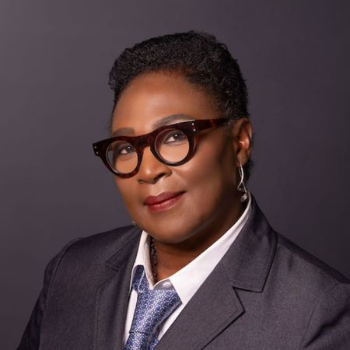
Dr. Desirée Cox
CEO and Founder, HEAlinc
Dr. Desirée Cox, MD, MPhil, PhD is a Rhodes Scholar, medical doctor, creative artist, and internationally respected thought leader in future health and regenerative medicine. She is the founder and CEO of The HEALinc and The HEALinc Future Health Innovation Summit, and is a Singularity University Social Impact Fellow. Educated at McGill University (Canada), Oxford University (UK) and Cambridge University (UK), Dr. Cox was one of 5 recipients of the 2019 International Advocacy Action Award at the World Stem Cell Summit in Miami, Florida. She was also a presenter at the 2018 Vatican ‘Unite to Cure’ Conference.
As an innovator, her career in the UK, Europe, North America, The Bahamas, and Latin America has spanned clinical medicine, academia, research and development, regulatory sciences, and the design, development, and implementation of high–impact health and social enterprises. Dr. Cox is a thought leader in future health innovation with 20+ years in the healthcare space and an impressive, rare and unique range of skills and capacities. In October 2017, she was honored by Oxford University as one of six alumni to have their portrait hung in the Great Hall at Pembroke College.
Since 2014, she has been spearheading the development of the stem cell and regenerative industry and future health innovation in the region. Her experience in healthcare consulting includes consulting for biotech companies and major pharmaceutical companies, including Amgen, GSK and Novartis, on pipeline therapeutic products and medical devices. At the 40th Independence Celebrations in 2013, the Bahamas Government honored Dr. Cox by issuing a 70-cent stamp into circulation bearing her photograph.

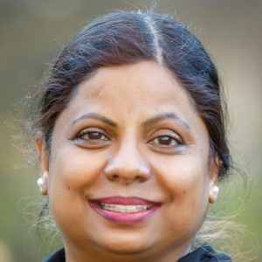
Dr. Jyothi Devakumar
Scientific Program Advisor
Professor of Health Research Methods, Evidence and Impact, McMaster University
Dr. Jyothi Devakumar is a scientist, entrepreneur, and lifelong longevity enthusiast. She holds a PhD in biotechnology, and her postdoctoral work was in in-vivo delivery systems. She has worked in various sectors of the industry, including working as part of a contract research organization liaising with several Ivy League pharma companies in the drug discovery space, as a scientific founder and CSO of two startups, and as a consultant in the regenerative medicine and longevity space. In the investing space, she has been a venture consultant, principal biologist and partner for a mid-sized venture fund. She is currently associated with the Longevity Tech Fund group of companies as the Chief Science Officer and partner. She has served on several scientific advisory boards and editorial boards, and she brings in scientific expertise, business strategy, and management experience with a multicultural, multi-country background.

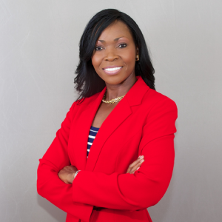
Donnette Russell-Love
Legal
CEO And President of Immigration Care Service, LLC

Born and raised on the Island of Grand Bahama, Donnette arrived in Miami Florida in the summer of 1990 to attend college and pursue her aspirations to become a journalist. To this end, she wrote for the school newspaper and served as news editor for two years. During that time, she became employed with a local television station and worked as an assistant weekend assignment desk editor, where she further fueled her passion for the dissemination of information.
By 1995, she shifted gears and ended up with a bachelor’s degree in psychology from Barry University. In 1997, she was accepted to The University of Miami School of Law and graduated with the class of 2000. During law school, she served as Vice President of the University of Miami Honor Council, as well as Community Service Director for the Black Law Students Association. Additionally, she served as special advisor of the Student Bar Association and worked as a law clerk for the Honorable Linda Singer-Stein.
After passing the Florida State Bar, she became employed with the Broward County Public Defender’s Office, where she worked from 2000 to 2004 as a criminal defense attorney. During that time, she worked as lead attorney and tried more than thirty-five jury trials. She was recognized as one of the office’s most outstanding trial attorneys, and in 2003 she was recognized as Trial Attorney of the Year.
Currently, Donnette owns and operates her own law practice that focuses entirely on immigration and border law, where she works with individuals throughout the Caribbean with US immigration issues and helps them to return to the US. She is also the CEO and President of Immigration Care Service, LLC in Florida, and the Program Director for the Immigration Resource Center, a nonprofit organization formed to aid English-speaking members of the Caribbean who need help overcoming literacy issues that prevent them from becoming naturalized US Citizens.

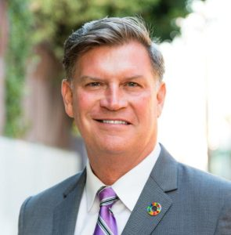
Arnold Strong
Logistics
Retired US Army Colonel
Col. (USA, Ret.) Arnold V. Strong brings over three decades of experience in teambuilding and leadership within diverse organizations as an innovator, communication strategist and systems integrator. With experience in public, private, defense, technology and start-up environments, Strong leads with a resilient focus toward his personal mission to inform, involve and inspire. A veteran of wartime service in Iraq and Afghanistan, as well as peacekeeping training and operations in Ghana, Bangladesh, and Egypt, the former Army Ranger has also served on the executive committee of a publicly traded company, served as CEO of an early sharing economy software company and remains a board member of several veteran-focused non-profits. His civil education includes a B.A. in English from the University of California, Los Angeles (UCLA) and a M.S. in Strategic Communication from the University of Oregon School of Journalism & Communication. He has earned academic certificates from the Harvard Business School, the University of Pennsylvania and the Portland State University Social Innovation Incubator. In his three-decade military career, Strong graduated from all levels of the Defense Information School (DINFOS) professional military officer education. He is a graduate of the Combined Arms Services and Staff School, the U.S. Army Command and General Staff College, the Infantry Officer Basic and Advanced Courses, the U.S. Army Ranger School and Basic Parachutist (Airborne) School. Col. Strong has also been a fellow or student at the Daniel K. Inouye Asia-Pacific Center for Security Studies (Honolulu) and the Kofi Annan International Peacekeeping Training Centre (Accra, Ghana). Among his awards and decorations, he is a recipient of the Legion of Merit and the Humanitarian Service Medal. He divides his time between the Greater Los Angeles area and The Bahamas. Mr. Strong is a partner of Unify Holdings Ltd.

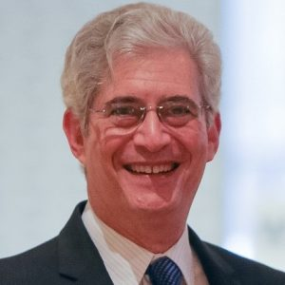
Bernie Siegel, JD
Executive Director, Regenerative Medicine Foundation
HEALinc Future Health Trailblazer Award

Bernard Siegel is the executive director of the nonprofit Regenerative Medicine Foundation (RMF), with a mission of accelerating regenerative medicine to improve health and deliver cures. Bernie founded and co-chairs the annual World Stem Cell Summit and RegMed Capital Conference, founded and serves editor–in–chief of the peer-reviewed “World Stem Cell Report” (AlphaMed Press).
In 2002, he filed the first court case relating to reproductive cloning and is widely credited for debunking the claim of the group claiming that they cloned the first baby.
As a recognized advocacy and policy expert in the fields of stem cell research, regenerative medicine and related subjects, Bernie works with the leading scientists and patient advocates, raising public awareness and educating lawmakers, the media and public. He is a frequent conference panelist and keynote speaker.

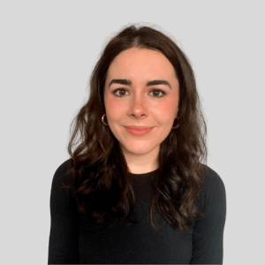
Erin Ambrose
Speaker and Sponsor Management

Erin Ambrose is the executive assistant to Dr. Desirée Cox and a program coordinator for the 2023 HEALinc Summit. With over a decade of experience in copyediting, ghostwriting, secretarial support, and personal assistance, Erin provides top-tier support to senior-level team members and aids in curating strategic administrative systems to champion the pursuit of scientific discovery and innovation. She is a magna cum laude graduate of Loyola Marymount University in Los Angeles, California, where she received her BA in Art History. A detail-oriented, published writer with an impressive capacity for organization and efficiency, Erin makes a positive mark on HEALinc through her consistent support of team efforts and her curiosity in the intersection of art, science, and technology.

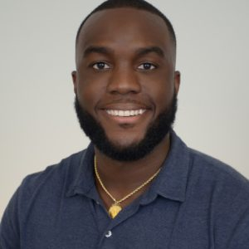
Crachad Laing
Director, Briding-the-Future Program, HEALinc

Crachad is currently Co-founder and Program Director at Project Limestone, Head of Math and Sciences at Windsor School, Albany, and Co-founder of STEM group, a technology consulting company. Born and raised in Nassau, Bahamas, Crachad has always had a passion for tinkering. When you live on a rock in the middle of the ocean, taking things apart and putting them back together can be quite an amusing activity. He got the opportunity to attend university in the United States, where he earned a BS in Civil Engineering Management. His professional journey has led him to education, where he has taken his engineering practices to the classroom. An engineer by training but an educator at heart, he has developed a passion for the development of young people in STEM practices. He aspires to inspire a generation of innovators.

