Include a title for this article and authors with their affiliation

Introduction
After the devastating hurricanes in 2017, the UCF I-Corps (define I-Corps) team decided to leverage the Lean Startup methodology to assist several teams with in the most impacted areas, including the U.S. Virgin Islands, parts of Florida, and the Bahamas. Using I-Corps methodologies and curricula had the potential to assist with disaster recovery efforts through bringing innovations into the commercial space, and the novel innovations may also prove successful in future prevention and recovery by leveraging innovative methods.
Upon meeting Dr. Desiree Cox at a medical tourism innovation conference shortly after the hurricanes, we proposed a joint collaboration among several U.S. islands, Florida, and the Bahamas. We reviewed the Nation Science Foundation (NSF) rules and discovered that additional outside sponsorship would be required to cover international travel and any costs incurred by a non-US citizen. Undeterred, our team decided that an I-Corps cruise between Florida and the Bahamas would allow our team members to collaborate internationally, and invite fellow researchers from the U.S. Virgin Islands and Puerto Rico interested in health and education redevelopment. It would also allow us to leverage partnerships with Doctors Hospital, and our US partners in Lake Nona Medical City and UCF, to produce a unique international experience. This experience would include the first few sessions of I-Corps with a hackathon-style collaborative work session. The hackathon-style session focused on disaster recovery and disaster kit planning through commercializing future innovations, which followed the Hacking For Defense (H4D) Mission Model Canvas and the Customer Discovery process while in the Bahamas and when returning to the U.S.
Technology is an indispensable aspect of our day-to-day lives. Computers, laptops, mobile phones, portable devices, the Internet or Things (IoT), and a multitude of innovations and emerging technologies in the biomedical world help create a better quality of life for individuals and organizations on a global scale. While there are countless examples of entrepreneurial innovations, the translation of these innovations into the market place and commercial success often meets with failure due to a lack of understanding of the true customer, product fit.
I-Corps
The Innovation Corps (I-Corps), developed by the National Science Foundation (NSF) and expanded to other organization including the NIH, was developed to increase the efficiency of the translational aspect of research. The program was quickly recognized as an effective tool. It was launched at the University of Central Florida (UCF) in January 2015, and was the first I-Corps program in the state of Florida. UCF’s I-Corps program has demonstrated its ability to reduce the gap between theoretical and practical innovative ideas.
Unlike traditional lecture-based courses, the I-Corps program is a flipped, practical, hands-on learning lab that helps teams live and engage the entrepreneurial experience through a systematic process of structured activities and mentorship by industry experts. Each participating team is required to perform customer outreach, in which they talk to customers, partners, and competitors to determine the feasibility of their current business models and assumptions, and to experience the chaos and uncertainty of how a startup actually works under pressure
Under the NIH version of the I-Corps program, the NIH and CDC foster the development of early-stage biomedical technologies, focus on teaching researchers how to gain a clearer understanding of the value of their inventions in the marketplace, and ultimately how to advance their technologies from the research lab into the commercial world. Their program is designed to complement activities within the scope of the parent SBIR Phase I (R43) or STTR Phase I (R41) grant or the Phase I portion of an SBIR/STTR Fast-Track grant (R44/R42, respectively), to help accelerate the commercialization of new products and services derived from NIH- and CDC-funded technical feasibility studies.
The NIH I-Corps program is supported through administrative supplement awards to active NIH or CDC SBIR and STTR Phase I grantees. Administrative supplement awards are intended only to support travel and other costs associated with the training program. A cohort (up to 24 teams per cohort) will be selected to participate in the I-Corps at NIH program, which is expected to last approximately eight weeks
Instructors for the course are certified in lean methods and instruction and each instructor is trained in delivering the I-Corps curriculum. It is anticipated that the feedback and learning gained during the I-Corps program will help inform future SBIR/STTR projects and commercialization strategies.
NSF I-Corps Sites and Nodes
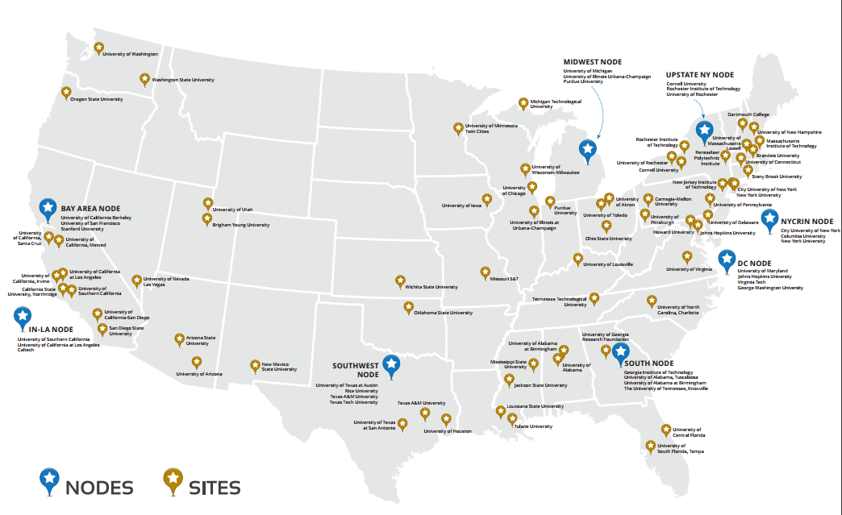
As shown in the following illustration, awarded I-Corps sites and nodes are centered around either established or emerging high-tech, entrepreneurial-based regions, which includes Central Florida along the Interstate 4 (I4) corridor between the Metro Orlando region and Tampa Bay:
Figure 1: National I-Corps Sites and Nodes

I-Corps Site Program Process
I-Corps offers proven curricula, tools, and methodologies such as the BMC and Lean Launchpad™ (LLP) to help entrepreneurs determine the feasibility of their potential venture. Through the Customer Discovery process, I-Corps requires team members to reach outside of the academic environment to speak with potential customers, and identify the impact their innovation may have within the market or on a specific industry. Using the BMC, the assumptions of the initial business models are then updated weekly based on the gathered information to help entrepreneurs make informed decisions based on actual data
Selected teams participate in a five-week, Socratic-delivered curriculum that takes them through the first four of nine sections of the Business Model Canvas (BMC) using a flipped classroom approach. Participants are expected to commit at least three to five hours per person per week to perform market research, customer discovery, and other commercialization-focused activities. It is important to establish that teams are interested in gaining new knowledge from I-Corps rather than focusing on receiving the $2,600 I-Corps grant. Teams conduct interviews and report their findings on a weekly basis. Instructors provide materials in class and use on-line educational delivery methods.

I-Corps Teams
Teams are generally comprised of three individuals: Entrepreneurial Lead (EL), Principal Investigator (PI) and Industry / I-Corps Mentor.

Entrepreneurial Lead (EL)
The entrepreneurial lead (EL), typically a postdoctoral researcher, graduate student, undergraduate, or other student, possesses relevant technical knowledge and a deep commitment to investigate the commercial landscape surrounding the innovation. The entrepreneurial lead should also be prepared to support the transition of the technology, should the I-Corps project demonstrate a level of readiness appropriate to leave the academic institution.

Principal Investigator (PI)
The principal investigator (PI) serves as the technical lead and project manager, who deeply understands the science and limitations of the technology. This role is typically assigned to a faculty member, Ph.D. or researcher.

Industry / I-Corps Mentor
This team member is typically a seasoned entrepreneur or business executive with more than 10 years of industry experience. The Mentor guides the team forward, serves as a sounding board, and assists the team in finding relevant research and individuals to interview. The mentor interprets results of the “tests” and offers honest opinions on feedback received. UCF I-Corps will provides each team with a mentor should they require one prior to beginning the program.

UCF I-Corps Site
In 2013, UCF became one of the original 16 NSF I-Corps sites and the first in Florida, affording the university with the opportunity to further enhance its entrepreneurial offerings and infuse the LLP methodology, curriculum, and approach as the de facto standard throughout the university and the Central Florida entrepreneurial ecosystem. Over the past five years, UCF has trained more than 150 entrepreneurial teams of faculty and student researchers. This includes a dedicated life sciences cohort conducted at and in collaboration with Florida Hospital Orlando, and several pilot programs conducted at and with industry partners such as the Boeing Corporation, Siemens U.S.A, and the Walt Disney Corporation. Further, diversity and inclusivity are at the core of UCF’s I-Corps program; of the more than 400 people who have participated in UCF I-Corps , 34.3% have been under-represented minorities.
As of this writing, the UCF I-Corps site has 130 teams that took the UCF I-Corps course from January 2015 to November 2018 and found that 57% of the teams engaged in a creating a startup as shown in Figure 1.
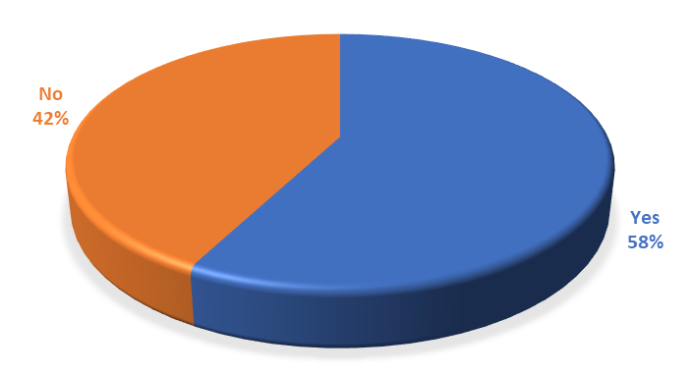
Figure 2: I-Corps Teams Engaging in a Startup (Jan 2015 – Nov 2018)
The 130 teams had a high blend of sectors that included healthcare, banking services and e-commerce, energy and environment, gaming, recreation and sports, education and research, nanotechnology, software and simulation tools, sports, and services and entertainment. The percentage of teams within each sector in shown in Figure 2. Examples of teams’ missions within each sector include:
- Healthcare: Heath data monitoring and storage, health training and awareness and development of innovative tests for various health issues and conditions.
- Software/Simulation Tools/Search: Flight simulator, Human task simulation tool and cloud services
- Banking Services/e-commerce: financial and credit card management services, online purchases and brick and mortar stores services.
- Energy/Environment: thermoelectric devices, wires to manage energy and solar panels
- Gaming/Recreation/Sports: modern game engine technology and engaging global community of fans in real time.
- Education/STEM/Research: interactive learning tools and instructional content and strategies
- Nano Technology/Materials: synthesizing quantum dots and low-cost manufacturing.
- Services/Entertainment: applications to provides access to nightlife and events, connect individuals in the music industry, connect Connects individuals to charitable causes and services to help people moving to unfamiliar areas know the neighborhood.

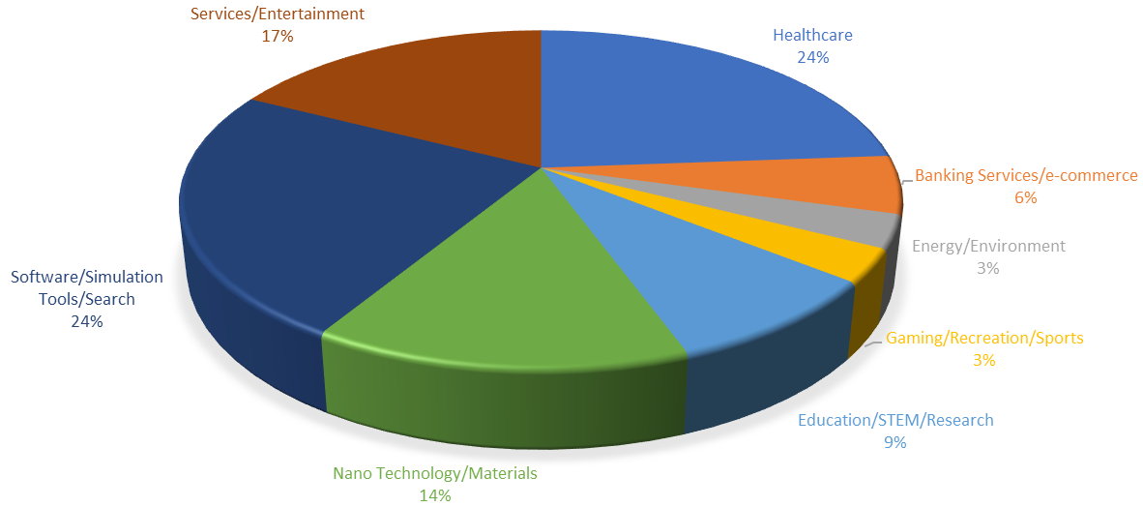
Figure 3: I-Corps Teams Sectors (Jan 2015 – Nov 2018)
I-Corps Nodes
The NSF Innovation Corps (I-Corps) Nodes are designed to support regional needs for innovation education, infrastructure and research. The Nodes will work cooperatively to build, utilize and sustain a national innovation ecosystem that further enhances the development of technologies, products and processes that benefit society.
The interconnected nodes of this network may be diverse in research areas, resources, tools, programs, capabilities and in geographic locations, while the network will have the flexibility to grow or reconfigure as needs arise.
I-Corps Nodes foster understanding on how to:
- Identify, develop and support promising ideas that can generate value;
- Create and implement tools and resources that enhance our nation's innovation capacity;
- Gather, analyze, evaluate and utilize the data and insight resulting from the experiences of the I-Corps Teams, and;
- Share and leverage effective innovation practices on a national scale to improve the quality of life for the American public.
Currently, there are nine I-Corps Nodes nationwide:
- Bay Area Regional I-Corps Node(BA)
- DC/MD/VA Regional I-Corps Node (DMV)
- I-Corps South Node (SOUTH)
- Innovation Node-Los Angeles (IN-LA)
- Midwest I-Corps Node (MWIN)
- New England Regional Innovation Node (NE I-Corps)
- New York City Regional Innovation Node (NYCRIN)
- Southwest Innovation Corps (SWICORPS)
- UNY I-Corps Node (UNY)
The nodes programs are longer than a sites program, cover the entire business model canvas and provide $50,000 per team. Many of the site program graduates apply for the nodes program.
Conclusion
Training students in entrepreneurship has a significant and positive impact on the business world, and it a critical component for regional economic stability and growth, and continued competitiveness in the knowledge-based global marketplace. Entrepreneurial education is varied, from basic knowledge through to in-depth, BMC and customer-focused programs such as NSF I-Corps; regardless of the program and its complexity, it has a strong impact on the participants of these programs, and prepares them to meet the challenges of the entrepreneurial process and make a true impact on the economy. It helps students gain the resources, knowledge, confidence, and skills to enter an industry and make their creative ideas into something tangible. Training also teaches students more about the entrepreneurship industry and helps them ascertain the skills to create successful businesses and, in turn, stimulate the economy.
Based on the success of the Bahamas program, further collaborative efforts including a follow-up visit to speak at the Bahamas Future Health Innovation Summit with other world renowned experts. The team agreed on future collaboration on activities such as semianrs, conferences, and writing articles such as the contents of this book. We anticipate further on-going collaboration that may be beneficial to our students, entrepreneurs and innovation programs in Florida, the Bahamas and throughout the Caribbean. The following information provides a brief summary of the goals and itinerary of the world’s first NSF I-Corps cruise. [Note to editor: Include the narrative from the brochure as additional insight for details on the program. Perhaps include pictures of the group from the cruise or the I-Corps event in action.]
What following information?
The pictures will require permission from each individual

https://venturewell.org/I-Corps/nodes-and-sites/

