Dear Parents, Guardians, and Family Members,

I hope this letter finds you well. My name is Crachad Laing, and I am the Director of the 2023 HEALinc Bridging-the-Future STEM Program.
You have elected for your child to participate in our Inaugural Bridging-the-Future STEM Program at the 2023 HEALinc Future Health Innovation Summit. This program is designed to provide students with the necessary exposure, resources, training and networking opportunities to quantum leap them into the next generation of scientists, inventors, innovators and problem solvers.
Our team has curated a curriculum that is modern, engaging, and most importantly, relevant. The goal of our program is to provide industry and application exposu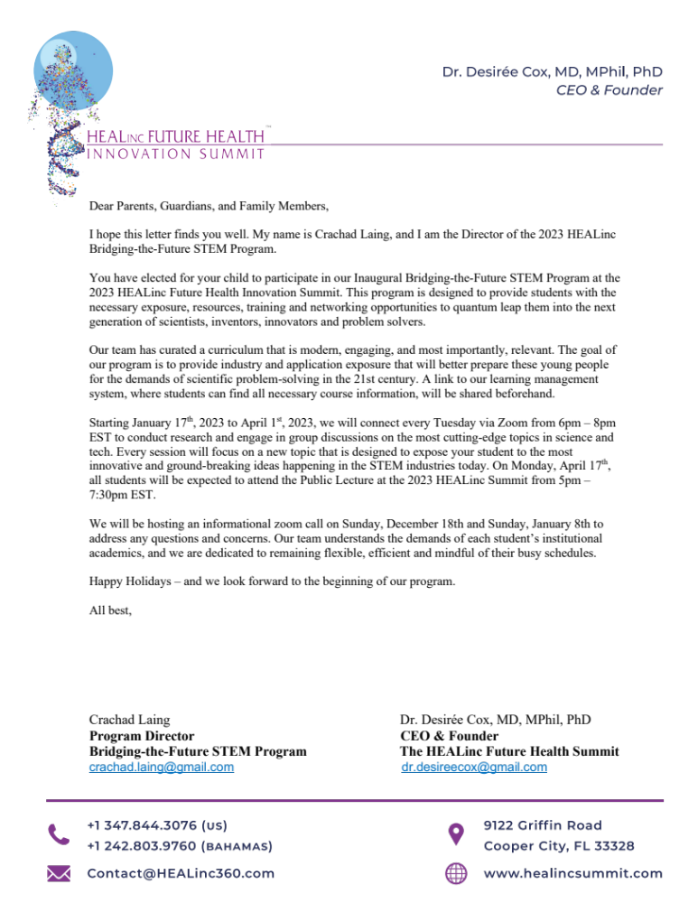re that will better prepare these young people for the demands of scientific problem-solving in the 21st century. A link to our learning management system, where students can find all necessary course information, will be shared beforehand.

Starting January 17th, 2023 to April 1st, 2023, we will connect every Tuesday via Zoom from 6pm – 8pm EST to conduct research and engage in group discussions on the most cutting-edge topics in science and tech. Every session will focus on a new topic that is designed to expose your student to the most innovative and ground-breaking ideas happening in the STEM industries today. On Monday, April 17th, all students will be expected to attend the Public Lecture at the 2023 HEALinc Summit from 5pm – 7:30pm EST.

We will be hosting an informational zoom call on Sunday, December 18th and Sunday, January 8th to address any questions and concerns. Our team understands the demands of each student’s institutional academics, and we are dedicated to remaining flexible, efficient and mindful of their busy schedules.
Happy Holidays – and we look forward to the beginning of our program.

All best,

Crachad Laing Dr. Desirée Cox, MD, MPhil, PhD
Program Director CEO & Founder
Bridging-the-Future STEM Program The HEALinc Future Health Summit
crachad.laing@gmail.com dr.desireecox@gmail.com

