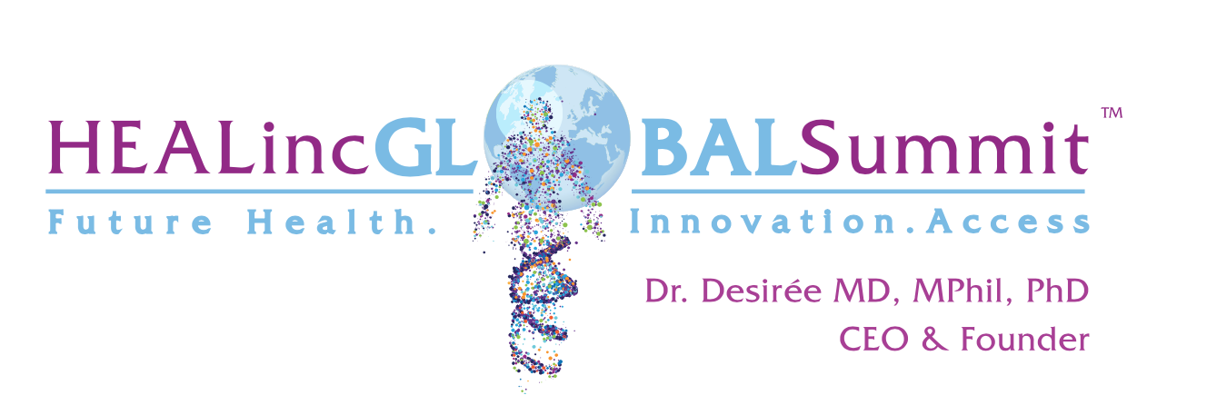

Hi, Dr. Desirée here. I hope this message finds you well.

As the CEO/Founder of the HEALinc Future Health Innovation Summits, I am delighted to
extend an exclusive opportunity to become a Speaker at our upcoming 2025 HEALinc Summit, scheduled for April 27th-29th at the Atlantis Resort on Paradise Island, The Bahamas. Our theme this year is New Opportunities in Healthy Longevity and Regenerative Medicine.

This year marks a significant evolution from our Inaugural Summit in 2018, setting the stage for
groundbreaking strides in regenerative health and longevity innovation. This year we’ll be making a special announcement about new laws and regulations coming on stream in The Bahamas that will advance the fields of longevity, stem cells and gene therapy globally.

HEALinc fosters collaborative pathways to expedite access to regenerative medicines, pro-longevity strategies, and elevating the quality of life for individuals facing unmet healthcare needs.
Becoming a Speaker of The HEALinc Summit presents unparalleled branding opportunities to align yourself with a diverse spectrum of stakeholders, including scientists, clinicians, investors, policymakers, regulatory bodies, commercial entities, and pharmaceutical firms.

I invite you to explore our updated website at www.healincsummit.com from January 8th, 2025, when early bird registration goes live. Discover an impressive lineup of luminaries, entrepreneurs, and influential thought leaders committed to sharing their expertise at the 2025 Summit. Among our confirmed distinguished speakers are trailblazers such as Bill Faloon (Life Extension), Professor Brian Kennedy (Center for Healthy Longevity, NUHS, Singapore), Professor Joshua Hare (University of Miami & Longeveron), Liz Parrish (BioViva), Dr. Ian White (Neobiosis), Professor Mike Chan (European Wellness Biomedical Group-Germany), Dr. Jennifer Garrison (Buck Institute, Stanford), Dr. Mattias Bernow (Cellcolabs, Sweden), and more. Our roster of internationally acclaimed speakers continues to grow, promising an inspiring convergence of visionary minds.

I look forward to discussing this Speaker opportunity with you. Join us as we collaborate to shape and propel the future of healthcare.

Here’s to vitality and enduring well-being,

Dr. Desirée Cox, MD, MPhil, PhD
CEO and Founder/Creator of The HEALinc www.healincsummit.com
Personal Email: dr.desireecox@gmail.com
Personal Email of Dr. Cox’s assistant, Erin Ambrose: e33ambrose@gmail.com

