Home:

Welcome to HEALinc360
Fueling Connections, Conversations, and Learnings Beyond The HEALinc Summit
Advancing the future of healthcare through cutting-edge technology, mentorship of future leaders, education on scientific breakthroughs, and creative healing products.
We've selected 3 great presentations from the 2023 Summits below. Become a member of HEALinc360 and get on-demand access to all videos from the 2024 HEALinc Global Summit, as well as past events.

Videos:

2023 HEALinc Summit, April 17th-19th

An Ecosystem of Wellbeing to Cultivate Mental Health, Post-Traumatic Growth, and Quality of Life
Dr. Cassandra Vieten, PhD
Director, John W. Brick Mental Health Foundation;
Director, Center for Mindfulness, University of California, San Diego
Cultivating mental and emotional health and wellbeing is crucial to not only living a long and healthy life, but elevating quality of life. In this presentation you will learn how mental health and wellbeing is being redefined, and how it can be cultivated using an ecosystem of factors that work together to foster emotional balance and psychological thriving. We will also discuss practices and tools for supporting post-traumatic growth, and how positive stress can be used to build resilience.

2023 HEALinc Summit, April 17th-19th

The Evolution of Human Aging Offers Insights into Potential Therapeutic Countermeasures
Dr. Ian A. White, MS, PhD, FACRM
CEO/CSO of Neobiosis and VP of The American College of Regenerative Medicine
The loss of tissue-specific stem cells capable of repair and regeneration in adults drives the biological process that we recognize as “aging.” Reversal and recovery of stem cell regenerative functions in aged individuals is now being realized thanks to advances in the field of regenerative medicine through the study of species, which are able to naturally slow and even reverse the aging process.

2023 HEALinc Summit, April 17th-19th

Senolytics and The Future of Longevity Medicine
Dr. Paul Robbins, PhD, Professor of Biochemistry, Molecular Biology and Biophysics; Associate Director of The Institute on Biology of Aging and Metabolism, University of Minnesota
What are senolytics? What are senolytics-based therapies, and why are they important for longevity medicine? This presentation discusses the importance of senolytics and the strengths and shortcomings of the current approaches to futuristic senolytics-based therapies.

Why Become Part of Our Community
There’s never been a better time to become a HEALinc360 member! From now until August 30th, we’re offering a special free membership rate in celebration of the upcoming 2025 HEALinc Global Summit. Sign up now to enjoy all the perks of a regular HEALinc360 membership (free until August 30th).
​
- Join our vibrant HEALinc360 community of like-minded professionals and creatives
- Get exclusive access to presentation videos from past Summits
- Participate in our exclusive HEALinc Summit Art Shows (which includes joining our "Emerging Creatives" initiative, with a personalized art page created just for you)
- Gain early access to key Summit information
- Stay up-to-date on our HEALinc newsletter and podcast
- Promote your company product/services

Here's what people are saying:
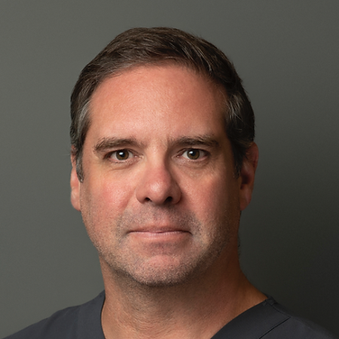
Dr. Ian White
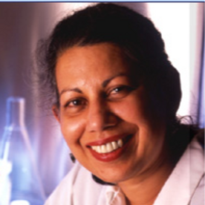
Dr. Pranela Rameshwar
“I loved this Summit. I enjoyed the broad scope and the different speakers in attendance. My favorite part was the panel discussions. More conferences need these sessions – it gives the
audience the opportunity
to interact.”
– Dr. Ian White, 2023/2024 HEALinc Speaker and Sponsor
“As someone deeply invested in continuous learning, research and as a speaker at the HEALinc Summit, I believe this forum is an invaluable experience as it contributes to a broad area of health. The fusion of art and science, coupled with insights from top-tier speakers, not only broadened my knowledge but also provided me with a unique platform to connect with like-minded professionals. The event's focus on cutting-edge scientific breakthroughs in longevity and regenerative technologies, making this summit a truly enriching and rewarding experience.”
– Dr. Pranela Rameshwar, 2023/2024
HEALinc Speaker
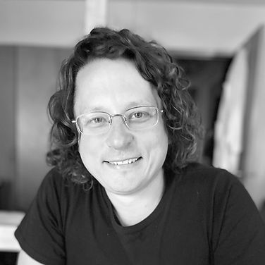
Greg Grinberg
“I loved the lineup of speakers and the many opportunities for real connection. The dinner
event on the beach was absolutely fantastic. [Dr. Cox] is a fantastic host. Her enthusiasm and profound affection and respect for all working towards our common cause comes through in her stage presence and thoughtful discussion questions posed to speakers.”
– Greg Grinberg, 2023 HEALinc Speaker and Sponsor
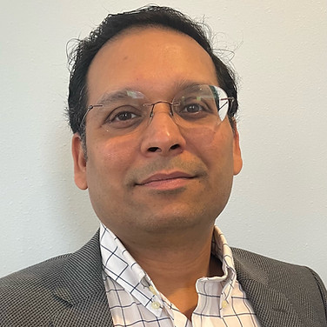
Rajeev Prasad
“As Founder and CEO of River Publishers, I am excited about our collaboration with the esteemed HEALinc Summit. By publishing scientific presentations from the Summit in the International Journal of Translational Sciences, we aim to contribute to the global dissemination of valuable research in regenerative medicine and longevity. This partnership aligns with our commitment to fostering knowledge exchange and promoting advancements in translational sciences, ultimately benefiting the wider scientific community and advancing the future of healthcare.”
– Rajeev Prasad, Founder and CEO of River Publishers
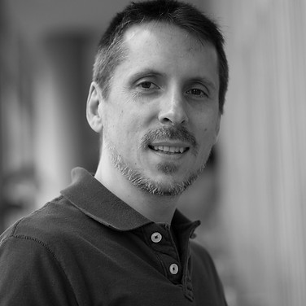
Dr. Jean Hebert
"What I most liked about the 2023 HEALinc Summit was the diversity of health/longevity-related speakers and topics covered, from the overview from the Minister of Health to the nuts and bolts of biological aging and how to counter it. The venue was also awesome."
– Jean Hebert, Ph.D.,
2023 HEALinc Speaker
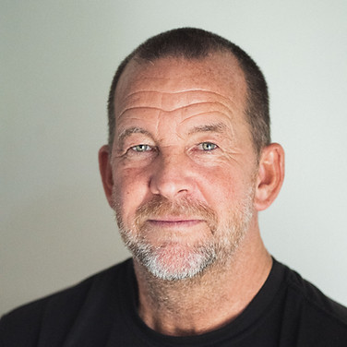
Dr. Jeff McNairy
“I liked all the speakers and topics discussed. Everything was very interesting. I appreciated how orderly,
on-point and timely each speaker was, as regulated by Dr. Cox.”
– Dr. Jeff McNairy, 2023/2024
HEALinc Sponsor and Speaker

AFFILIATES:

Our sponsors and partners help make the HEALinc Future Health Summits a success. We extend a special thanks to the 2024 HEALinc Summit sponsors and partners.

We are delighted to introduce our HEALinc360 Affiliates packages, which are personalized to suit the needs of our many affiliates.
Our Affiliates packages are for highly motivated biotech teams and companies committed to developing and delivering high-quality regenerative therapies and improving access to longevity and regenerative therapies for patients everywhere.
​
Benefits include:
- Supporting longevity and regenerative therapy ecosystems in the Caribbean and other jurisdictions outside the US
- Speaker/sponsor benefits at the 2025 HEALinc Summit, including a booth in Exhibition Hall
- 35-minute speaking slot on the main stage
- Other speaker/VIP networking opportunities at the HEALAfrica Festival (starting October 2024) and the virtual HEALinc Summits (starting January 2025)
Contact us to schedule a meeting to discuss the HEALinc360 Affiliates package that’s right for you.

HEALinc Summit Videos:

An Ecosystem of Wellbeing to Cultivate Mental Health, Post-Traumatic Growth, and Quality of Life
The Evolution of Human Aging Offers Insights into Potential Therapeutic Countermeasures
Senolytics and The Future of Longevity Medicine

Photo Gallery:

Photo Gallery
Innovative minds are crafting the future of health and medicine by merging various fields and rapidly evolving technologies. The HEALinc Summit embodies this synergy, fostering a sense of community and encouraging cross-disciplinary collaboration. Embrace this opportunity to become part of our dynamic family.

Plans & Pricing:

HEALinc360 Members

Becoming a HEALinc360 member not only affords you the unique opportunity to network and connect with like-minded individuals in healthcare, but it also opens doors to a wealth of resources about the future of regenerative wellness and longevity. Our global community of scientists, doctors, thought leaders, CEOs, entrepreneurs and medical professionals create a cohesive, supportive environment that encourages future health education and collaborative innovation. We are much more than just a group - we are a movement. Join us as we continue to champion the future of healthcare through cutting-edge technology, scientific breakthroughs, creative healing products, and the mentorship of future leaders.

Join Now for FREE! Monthly rate kicks in on August 30th, 2024.

VIP Member
$1,0001,000$
Every year
Become part of our community!

Select
- Exclusive VIP HEALinc Summit dinner invitation
- Inclusion of your name on VIP Members' Circle pages
- Feature your articles in our weekly HEALinc360 newsletter
- Much, much more!
HEALinc 360 Member
$00$

Become part of our community!
Free Plan
Select
- Our community of scientists, healthcare and wellness experts
- Exclusive access to presentation videos from past Summits
- Participate in our exclusive HEALinc art shows
- Gain early access to key Summit information
- Stay up-to-date on our HEALinc newsletter and podcast
- Get a 10% discount on Summit registration
- NOTE: STARTING AUGUST 30th, the monthly charge will be $7.99

