Annals of Zoology
How Scientists Started to Decode Birdsong
Language is said to make us human. What if birds talk, too?
By Rivka Galchen
October 14, 2024
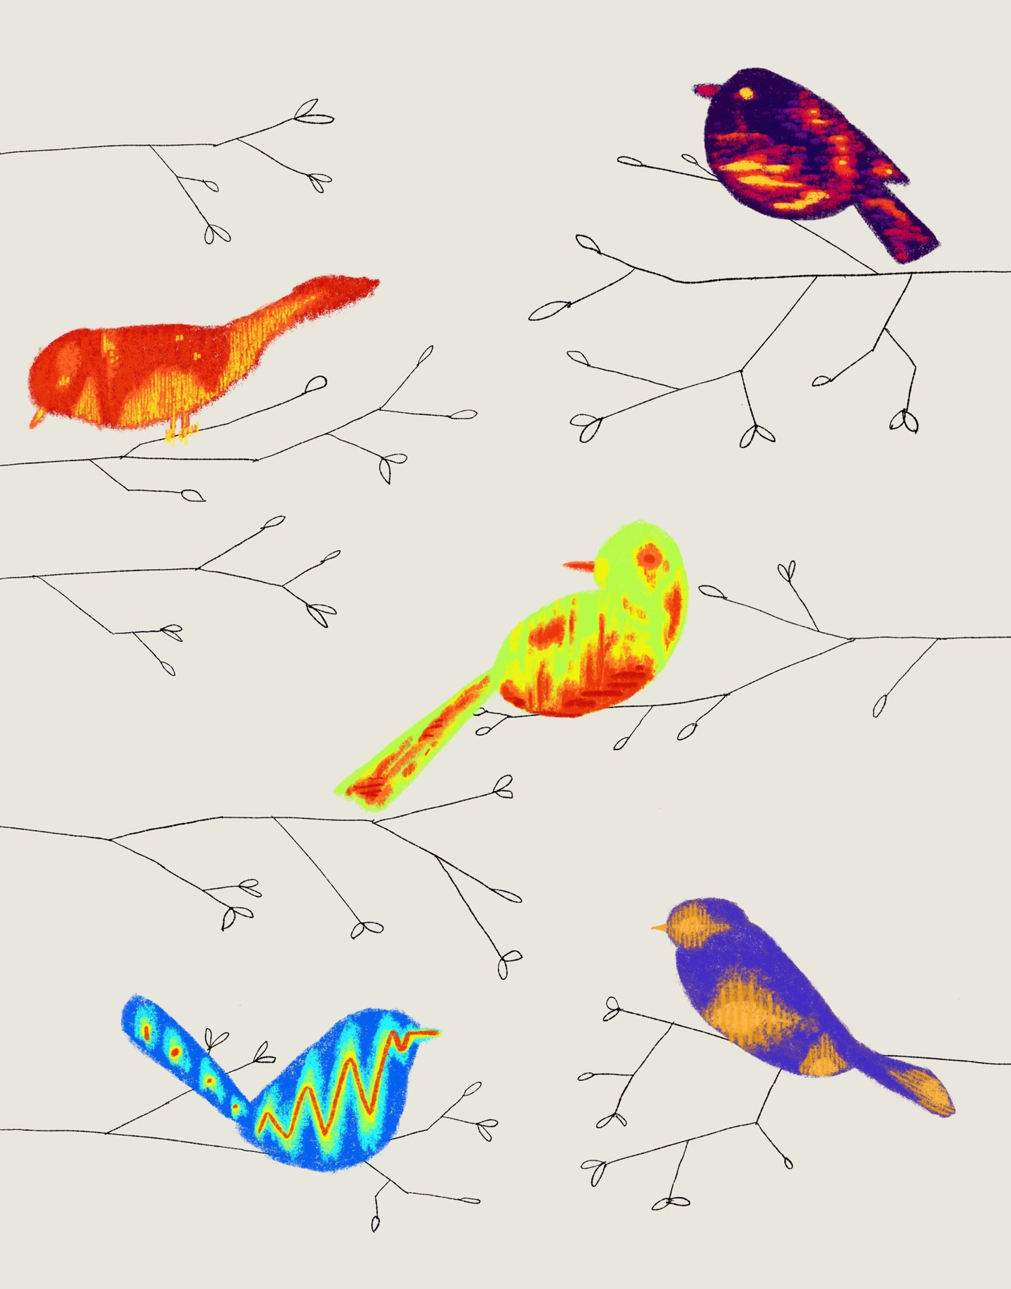
“Social birds . . . are constantly chatting to each other,” Mike Webster, an animal-communication expert at Cornell, says. “What in the hell are they saying?”Illustration by Jared Nangle
On a drizzly day in Grünau im Almtal, Austria, a gaggle of greylag geese shared a peaceful moment on a grassy field near a stream. One goose, named Edes, was preening quietly; others were resting with their beaks pointed tailward, nestled into their feathers. Then a camouflaged speaker that scientists had placed nearby started to play. First came a recorded honk from an unpartnered male goose named Joshua. Edes went on with his preening. Next came a honk that was lower in pitch than the first, with a slight bray. Edes looked up. As the other geese remained tucked in their warm positions, incurious, Edes scanned the field. He had just heard a recorded “distance call” from his life partner, a female goose whom scientists had named Bon Jovi.
Edes and his fellow-geese live near the Konrad Lorenz Research Center for Behavior and Cognition, which is named for a Nobel laureate whose imprinting experiments, in the nineteen-thirties, convinced goslings that he was their mother. (They took to following him in a downy line.) Greylag geese in the area have been studied continually ever since. The director of the center, a biologist and bird ecologist named Sonia Kleindorfer, showed me footage of Edes to demonstrate the subtlety of goose communication.
Geese maintain elaborate social structures, travel in family groups, and can navigate from Sweden to Spain. In a fight, an unpartnered greylag goose has a higher heart rate than a partnered one, and the heart rate of a recently widowed goose can remain depressed for about a year. These birds have things to discuss. Still, geese are not the Ciceros of the bird world. A lyrebird sings long, elaborate songs; ravens really can say “nevermore.” Geese are known for nasal honks. How much nuance can there be in a honk?
Greylag geese, it turns out, have at least ten different kinds of calls. “We are completely underappreciating the way they communicate,” Kleindorfer told me. “They give a departure call when they leave, and a contact call after they arrive. They know if their allies are there, if the bold geese are there. There is so much information that geese are getting from calls.”
Bird vocalizations are usually divided into songs and calls, but these are wobbly categories. What is designated a song in one species may be shorter in duration than what, in another species, is termed a call. Onomatopoeic groupings such as tseets, chirrups, rreeyoos, seeew-soooos, and dahs are also indeterminate: people transcribe the same sounds in different ways, and no bird version of the Académie Française exists to adjudicate. The vocalizations of birds are fundamentally incommensurate with human ones. We have a larynx and two vocal cords; they have what’s called a syrinx, which is a bit like having two larynxes that you can use at the same time.
Kleindorfer, the daughter of a mathematician and an actress, looks like a cross between a hiker and the film star Sophia Loren. From February to April, she researches Darwin’s finches in the Galápagos; from September to December, songbirds in Australia; and, for the rest of the year, the geese outside her office door. Early in her education, as an undergraduate at the University of Pennsylvania, she was taught that “male songbirds sing, females don’t, and if females do sing it’s an error.” The attitude at the time, she told me, was that “females are drab, inconspicuous, and quiet.” A few years after earning a Ph.D. in zoology at the University of Vienna, Kleindorfer took a job as a research biologist at Flinders University, in Australia, where songbird species originally evolved. “Imagine my surprise,” she told me. “I heard all these females singing songs as complex as the male songs.” Much of her ensuing career has focussed on bird vocalizations that were either underappreciated or unknown.
Kleindorfer decided to study bird eggs and early development, which were then neglected research topics. “Maybe this was because only females have eggs and I was a woman in science,” she told me. “I don’t have a better reason.” Kleindorfer had noticed that mustached-warbler chicks seemed to respond to the alarm calls of adult warblers, even though the thinking at the time was that such calls were directed at other adults, or possibly at predators. “If I put a snake nearby, the parental alarm call made the chicks in the nest jump,” she said. “If I put a marsh harrier”—a hawklike predatory bird—“nearby, the response to the parental alarm call was that the chicks would duck.” The chicks were responding appropriately to different alarm calls—a satisfying finding.
Kleindorfer also studied the superb fairy wren, a songbird that weighs about as much as a walnut and sports a flirty, upright tail. Despite their fanciful names, fairy wrens are commonplace in Australia. They are socially monogamous but sexually promiscuous—they are essentially in open marriages—and they bring up their young collectively. Arguably, they have even more to chat about than geese do. Fairy-wren nests are about the size of cupped human hands, built to contain pale, speckled eggs that are smaller than thumbnails. Kleindorfer and her team wired up nests with cameras and microphones and soon discovered something that they hadn’t known to look for. “The mothers in nests were producing an incubation call—a call to the eggs,” she told me. It was like a lullaby. Why would a mother bird make any sound that could attract predators to the nest? “Songbird embryos don’t have well-developed ears, so this was completely unexpected,” she said. “That started a twenty-year project—why is she calling to the eggs?”
The team compared incubation calls to the begging calls of young chicks. “It was very odd,” Kleindorfer recalled. “Each nest had its own distinct begging call.” What’s more, each begging call matched an element from the mother’s incubation call. This suggested, startlingly, that birds could learn a literal mother tongue while still in ovo. (Humans do this, too; French and German babies have distinct cries.) Even “foster” chicks, who as eggs were physically moved from one nest to another, learned begging calls from their foster mothers, rather than from their genetic mothers. This was big news in the ornithology world. “The paradigm of how songbirds learn—after hatching, from their father’s song—was overthrown,” she said. The same process was soon documented in more songbird species.
Language is often cited as the quality that distinguishes us as humans. When I asked Robert Berwick, an M.I.T. computational linguist, about birds, he argued that “they’re not trying to say anything in the sense of James Joyce trying to say something.” Still, he and Kleindorfer both pointed out that humans and songbirds share a trait that many animals lack: we are “vocal learners,” meaning that we can learn to make new sounds throughout our lives. (Bats, whales, dolphins, and elephants can, too.) “To me, the most amazing thing is that every generation of vocal learners has its own sound,” Kleindorfer said. “So, just like our English is different from Shakespeare’s English, the songbirds, too, have very different songs from five hundred years ago. I am sure of it.” We humans have long tried, often mistakenly, to differentiate ourselves from nonhuman animals—by arguing that only we have souls, or use tools, or are capable of self-awareness. Perhaps we should see what the birds have to say.
Animals have prominent speaking roles in many of our oldest stories. Eve has a memorable conversation with a snake. In Norse mythology, two ravens, Huginn and Muninn, serve as spies to the god Odin, whispering to him the news of the world. In many cultures, the “language of birds” refers to a divine or perfect language—the language of angels. In the scientific realm, however, the notion that nonhuman animals use language is often seen as foolish or naïve. Some birds may be excellent mimics, like parrots, but they can also mimic chainsaws or barking dogs; scholars don’t usually consider imitation a form of understanding. The prevailing dogma is that birds sing either to impress mates or to defend their territory. (I suspect that most of human communication could also be slotted into those categories.) In college, I was taught a stranger but similarly diminishing idea: that songbirds sing in the morning to burn fat, so that they are light enough to fly around during the day. Apparently, this idea is no longer taken seriously.
Video From The New Yorker

Eco-Hack!: Saving Desert Tortoises from Extinction

Even among species we view as being closer to ourselves, such as primates, scientists have tended to talk about “communication” instead of “language.” But it’s tricky to say where the line is, or what we mean by “communication,” since even bacteria communicate, as Berwick pointed out to me. “I think it’s best to think of language not as speech but as a cognitive ability in the mind that sometimes leads to speech,” he said, giving the example of inward conversations we have with ourselves. The linguist Noam Chomsky has said, “It’s about as likely that an ape will prove to have a language ability as there is an island somewhere with a species of flightless birds waiting for humans to teach them to fly.” Chomsky’s 2017 book on the evolution of language, co-authored with Berwick, is titled“Why Only Us.”
Over the years, however, some researchers have looked closely at the contexts in which certain animal vocalizations are made. In the late nineteen-seventies, two primatologists, Dorothy Cheney and Robert Seyfarth, were studying vervet monkeys in Kenya. Vervets have dark faces and pale fur; they are about the size of a small backpack and are hunted by pythons, eagles, and leopards. Cheney and Seyfarth documented something remarkable: one recorded vervet vocalization made vervets look up, presumably for eagles; another made them look down, presumably for pythons; and a third sent them running up into the trees, a good defense against approaching leopards. Young vervets sometimes use these calls faultily, perhaps sounding a leopard alarm for a warthog. But they get better as they grow up. They learn.
A newer generation of scientists has been trying to understand bird vocalizations. The alarm calls of Siberian jays can be said to have been partially translated. One of their screeches indicates a sitting hawk (which prompts other jays to come together in a group), another a flying hawk (jays hide, which makes them difficult to spot), and a third a hawk actively attacking (jays fly to the treetops to search for the attacker, and possibly flee). When cheery birds known as tufted titmice make a piercing sound, other titmice may respond by collectively harrying an invading predator. Some birds even lie. Fork-tailed drongos—common, innocuous-looking little dark birds that live in Africa—sometimes mimic the alarm calls of starlings or meerkats. Duped listeners flee the nonexistent threat, leaving behind a buffet for the drongo.
Upon seeing an owl, a chickadee might sound a loud chick-a-dee-dee-dee, adding dees in relation to how dangerous the predator is perceived to be. This call is also understood by nuthatches, which will join in to mob and harass the predator, forming a kind of defensive alliance. If you record an Australian bird warning of a nearby cuckoo—cuckoos leave their eggs in the nests of other species and often kill their step-siblings—birds in China will understand the call.
Advertisement
Kleindorfer considers Cheney and Seyfarth, the primatologists, to be important sources of inspiration. After she moved to Australia, she and her colleagues built up a sound library of Australian songbirds. They also made recordings of quieter, familial bird sounds, such as the incubation calls. Each family unit, they discovered, had its own “familect,” a system of sounds that chicks learn from their parents. Curiously, chicks seemed to adopt sounds sung either by their mother or by their father—but they avoided the sounds used by both parents. If the mother sings ABCXYZ and the father sings ABCGHI, then the chicks tend to sing the sound units X, Y, Z, G, H, and I. It’s as if the young birds separate themselves from their parents by not speaking the shared sounds, but also stay close to their parents by learning what’s unique to Mom and unique to Dad. When female chicks grow up, they are attracted to mates whose repertoire is familiar (he’s one of us!), but not too familiar (he’s not my brother or dad).
Birds in general are turning out to have intellectual abilities far greater than most people had imagined. It’s not just that parrots and crows can do math as ably as young children, or that scrub jays cleverly cache and then uncache their food to fool other jays. Even inconspicuous and uncelebrated birds are capable of learning, and of sharing their learning with others. In the nineteen-twenties, tits from Swaythling, England, figured out how to open the caps of milk bottles, and by the late forties tits across Ireland, Wales, and England had learned the trick. If language is more a capacity than it is a speech act, it seems possible that birds possess it.
In 1889, Ludwig Paul Koch, an eight-year-old boy in Frankfurt, Germany, received a present from his father: an Edison phonograph and some wax cylinders for recording sounds. The oldest known audio of birdsong is young Koch’s recording of his pet white-rumped shama, a smallish songbird with a dark head, an orange body, and feathers that resemble a white bustle on its glossy black tail. A shama sings like a small chamber orchestra, with slippery, percussive, and sweet sounds in phrases of varying lengths. Many similar recordings followed. In 1929, the Cornell Library of Natural Sounds—now the Macaulay Library—was started with a few hard-won recordings of a sparrow, a wren, and a grosbeak. (Cornell is to ornithology what the Juilliard School is to music.)
Koch, who was Jewish, became a professional musician but fled Germany in the nineteen-thirties. In England, he became a beloved presence on BBC radio. Sounding like a singsong, sanguine sibling of Werner Herzog, he guided Brits through the charms of birdsong. (A yellow icterine warbler, he told listeners, “frequently called me by my Christian name . . . Ludwig, Ludwig.”) Koch often expressed the hope that such recordings might be used for science. Many years later, they were.
In 2010, Grant Van Horn was an undergraduate at U.C. San Diego and working in a computer-vision and machine-learning lab led by the computer scientist Serge Belongie. The lab was looking for a good data set to train an image-recognition program. At the time, Van Horn told me, many of the top images on Flickr, the popular photography Web site, were of birds. Van Horn was no birder, but he wanted to see if he and his colleagues could teach a computer program to distinguish between closely related species, such as a house wren and a marsh wren. As it turned out, they could.
The lab’s work soon attracted the attention of ornithology researchers at Cornell. Van Horn recalls them telling him and his colleagues, “in the nicest possible way, ‘Look, guys—this data set is quaint and poorly constructed, and the species that you chose to study make no sense. Do you want to effectively redo this whole process, but do it in collaboration with us?’ ” When Van Horn visited Cornell, the scientists took him out birding every morning and evening, and he remembers wishing that he could take their expertise back to California with him. The collaboration eventually helped the Cornell Lab of Ornithology develop Merlin Bird ID, an app that could reliably identify several hundred species of bird from photographs. It proved immensely popular—but the Cornell team had always had larger ambitions. “They kept asking, ‘How can we do this with sound?’ ” Van Horn recalled. That was what the scientists were most interested in. But he assumed that auditory recognition was outside his expertise—until, out of curiosity, he attended a workshop on audio-related machine learning.
“I kind of had an epiphany,” Van Horn said. Sound recognition often relied on spectrograms, visual representations of sounds similar to what you see in audio-editing software. Mike Webster, an animal-communication expert at Cornell who directs the Macaulay Library, and who worked on Merlin, told me, “When people figured out how to visualize sound—how to actually take measures of it—that led to just an explosion of research and understanding about how and why birds communicate with each other.” Much of the work in sound recognition, Van Horn realized, was actually visual: “I thought, Let me bring these computer-vision skills to bear.” An early test could differentiate between recordings of alder flycatchers and willow flycatchers.
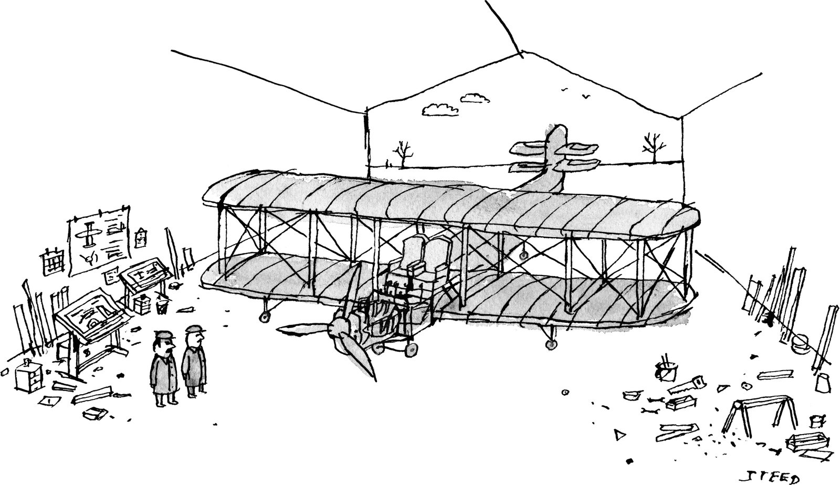
“It’s still too heavy. What if instead of two armrests we just share one?”
Cartoon by Edward Steed
Copy link to cartoon
Link copied
Shop
Open cartoon gallery
In 2021, the number of bird recordings in the Macaulay Library, many of which were submitted by citizen scientists, reached a million. That same year, Cornell released Merlin Sound ID, which was originally trained on around two hundred and fifty hours of bird sounds, as well as on background noises (whistling wind, passing cars), all manually annotated by experts. At first, Sound ID could identify about three hundred different North American birds, with a bias toward those found around Cornell. Three years and a million additional recordings later, Sound ID can now very accurately identify about fourteen hundred species. The lab hopes that number can grow to roughly eight thousand, out of around eleven thousand known bird species.
Amateurs now have a remarkable ability to recognize the birds that are cooing or chirping—which has generated more interest in birds and directed more citizen-science recordings to the Macaulay Library. But decoding the bird vocalizations is another matter. One problem is that certain sorts of recordings are more plentiful than others. “Most of our database is songs,” Webster said. “We can now understand songs at a level that we couldn’t before.” Alarm calls are also relatively easy to capture. But something like nest chatter, which is quieter and less predictable, is more elusive: “There are whole categories of bird communication that we’ve hardly even started to look at.” Webster isn’t expecting there to be straightforward translations of birds’ sounds into human language; animals live in perceptual worlds that are just too different from our own. Still, he sees machine learning as a powerful new tool. “There are a lot of people who have dreams of using A.I. to allow us to decipher what animals are saying,” he told me.
After three decades of research, Webster is preparing to retire. When I asked him what he hoped the next generation of scientists might learn, he thought for a moment. “Well, social birds. They are constantly chatting to each other,” he said. “Making little noises. Often very quietly. It’s like they’re having a whisper conversation. What in the hell are they saying to one another? I’d really like to know.”
Until my eleven-year-old daughter became interested in birds, I barely knew a starling from a sparrow. She once asked me, incredulously, “You’re saying you can’t tell a male sparrow from a female?” For a long time, we lived just east of the Lincoln Tunnel, where “birds” meant pigeons and seagulls, but within weeks of moving to Brooklyn we saw a red-tailed hawk on a lamppost. My daughter began talking about dark-eyed juncos and tufted titmice and peregrine falcons; we started visiting bird sanctuaries, and I eventually outgrew my favoritism toward mammals. Like millions of others, we started to use Merlin Bird ID. Usually, we heard birds before we saw them. Some local sparrows nesting in a hollow pole on our block sounded like Laurel and Hardy bickering.
“Anthropomorphism” is a familiar term that describes a common error: the assumption that animals have human qualities. A less familiar term, “anthropectomy,” also describes a kind of error—that of baselessly assuming animals don’t share certain qualities with us. Which kind of error is a person more likely to make? Or are these not errors but, rather, starting points, with someone like Jane Goodall starting from the premise that 98.7 per cent of our DNA is shared with chimps, and someone else starting from the fact that we humans have sequenced our own DNA and no other species has even invented pliers? Since we’re still arguing about what language is, it’s difficult to say which assumption about animal language is more presumptuous.
Toshitaka Suzuki first started to wonder if birds speak their own language during his last year of college, at Toho University, in Tokyo. He was on a hike in the forests of Karuizawa when he witnessed what struck him as a strange drama among some common Japanese tits, birds that resemble chickadees. One tit called out dee-dee-dee near some scattered sunflower seeds; other tits flew over and began to eat. “Then one bird called out hee-hee-hee, and the birds all flew off into nearby bushes,” Suzuki recalled. He could see no reason for them to abandon their feast.
Seconds later, a sparrow hawk swooped in; all of the tits had escaped safely. “I thought, Maybe hee-hee-hee means ‘Hawk incoming, run away!’ ” Suzuki said. He already took birds seriously and knew a lot about them; he had studied under Hiroshi Hasegawa, a scientist who was central in bringing the short-tailed albatross back from near-extinction. But Suzuki had thought of bird vocalizations as, for the most part, emotive, like music, or as a kind of beautiful nonsense. He has now devoted eighteen years to researching tits and their communication. “I couldn’t have imagined how long I would be studying tits, because I love other animals as well,” Suzuki told me. Like many researchers, he hopes that the more we understand birds the likelier we are to protect them.
Advertisement
In April, 2023, at the University of Tokyo, Suzuki founded what he calls the world’s first laboratory specifically devoted to animal linguistics. He argues that more work should be done to explore what cognitive abilities underlie human language—and then to investigate whether these abilities are present in animals. (In many ways, this approach mirrors the work of Berwick and Chomsky, but leads to different conclusions.) Some are skeptical of his push to compare animal communication to human language. “It’s just so far removed from the complexity of human language that it doesn’t make sense to use the same word,” Todd Freeberg, an animal-communication researcher at the University of Tennessee, told me. When a chickadee amplifies a call by adding dees, some researchers might say that they are engaging in referential signalling, by adjusting their call to the seriousness of the threat. But Freeberg points out that extra dees could also be a result of heightened arousal, in general—less a conscious message than a physical response.
Like Kleindorfer, Suzuki took an interest in nests. Early on, he showed that chicks in nesting boxes respond to a call associated with crow sightings by crouching, and to a call associated with snakes by fleeing the nest altogether. The arc of Suzuki’s research has, to some extent, followed a series of arguments about what qualities are required for communication to rise to the status of language. Humans are noted for their ability to form a mental image—a concept—of what they are communicating. Suzuki designed an experiment in which he played a variety of calls and moved a stick in a variety of ways; only when he played a snake-alarm call and moved a stick in a snakelike way did the birds tend to react as if a snake were present. To him, this suggested that they had some concept of snake-ness. (He said that the experiment was inspired by the way that humans perceive shapes in clouds.)
In a 2023 study, Suzuki showed that tits responded differently to a recorded ABCD call than they did to a remixed version of the call, such as DABC—a potential challenge to linguists who see sophisticated syntax as being unique to human language. (Studies of southern pied babblers and of chestnut-crowned babblers also have interesting syntax results.) Symbolic gestures—also often considered unique to humans—were addressed in a particularly adorable Suzuki paper, in 2024. His team watched mated pairs of tits as they entered their nest boxes. The opening to each nest box was small, allowing only one bird at a time to pass. But sometimes one bird, usually the female, fluttered its wings in what seemed to be an “after you” gesture. The other bird would then enter the box first. The fluttering didn’t point at the nest box. In Suzuki’s view, this suggested that the flutter was not a simple indication but, instead, a symbolic gesture—another item crossed off on the unique-to-human-language list.
Perhaps the nest-box study needs to be replicated; perhaps there are alternative interpretations of the results in the concept and syntax studies. Suzuki is open to such critiques. But he is also skeptical of many prominent ideas in linguistics, such as Chomsky and Berwick’s argument that a slight evolutionary change in the brain unlocked a new linguistic capacity in humans: the unique and powerful ability to connect individual units in a hierarchical and expressive way. (Suzuki thinks that language more likely emerged bit by bit.) By Suzuki’s latest count, the tit’s vocal repertoire has more than two hundred distinct calls and phrases. He has many more experiments to conduct.
Recently, my daughter and I took an early-morning trip to Little Stony Point, in the Hudson Valley, and met up with two people who have no particular need for an app like Merlin Bird ID. Andrew C. Vallely does field-ornithology work for the American Museum of Natural History; he’s become friends, by way of bird-watching, with Jeffrey Yang, an editor at New Directions Publishing. Yang had been seeing a lot of migrating warblers, which had flown well over a thousand miles—did we want to come try our luck? At his suggestion, I warned my daughter that there was no telling whether we’d actually see any.
About five minutes down the trail, in a not particularly distinguished wood (we could still hear cars and an excavator across the river), we saw a kingfisher diving and an adolescent eagle on a bare tree. As we walked, stopped, walked, stopped, we repeatedly heard what sounded like the call of a red-tailed hawk. But it soon became clear, at least to Vallely and Yang, that it was a jay mimicking a hawk. “They do that sometimes,” Vallely told me.
“To scare away other predators?”
“That’s one thought,” he said. “Vocal mimicry can be pretty mysterious.”
We heard the “tea kettle tea kettle” call of a Carolina wren; it sounded like a game of marbles to me. We saw a warbling vireo, a Cape May warbler, a blackpoll warbler, and a black-and-white warbler—birds so small that it was difficult to fathom how far some of them had travelled to be there. We heard little chips that sounded like a window being cleaned; a crickety decrescendo that was not made by crickets; a sound like a trill running into a wall; a high-pitched three-fast-one-slow, like a child playing Beethoven’s Fifth Symphony. We encountered forty-four species by Yang’s able count, and at the very end we saw a Swainson’s thrush, who apparently wasn’t in the mood to show off. Bird-watching, I thought, is a misleading term. So much of the fleeting, present-tense pleasure of it is bird-listening.
The quiet of the pandemic brought natural sounds to the foreground for Maddie Cusimano, who was then a graduate researcher of auditory perception at M.I.T.’s Center for Brains, Minds, and Machines. “Like a lot of people, I had the sense of getting to know the birds around me for the first time,” she told me. Two doves were often visible from her window; she read that, in some dove pairs, one bird sings to the other in the mornings, and in the evenings the roles reverse. Cusimano was familiar enough with machine learning that, when she tried out bird-identification apps, she thought, I could help make this kind of thing.
Cusimano is now a senior scientist specializing in A.I. research at the Earth Species Project (E.S.P.), a nonprofit dedicated to “using artificial intelligence to decode non-human communication.” E.S.P.’s current efforts examine such species as zebra finches, crows, and beluga whales, but its early work has been preoccupied with preliminary challenges: the “cocktail-party problem” of picking up individual sounds in a noisy environment; how to correlate particular noises with the precise contexts in which they occur. “It’s like we want to write the Magna Carta, but first we need to make the quill,” Katie Zacarian, the organization’s co-founder and C.E.O., told me. Zacarian isn’t expecting a Google Translate for animal languages, but she does believe that we can understand animals better. She remembers that, as a kid, people often brought her father, an entomologist, pictures and specimens and asked: What is this? Her mother was a researcher and an administrator of multilingual education programs. “There’s this underlying current, in their work, of decoding,” she told me.
Advertisement
When I talked to Cusimano, on Zoom, she pulled up a collection of sound files of crows. Her data set comes from Daniela Canestrari and Vittorio Baglione, researchers at the University of León, in Spain, who have been studying Spanish carrion crows for more than twenty-five years. Cusimano has spent countless hours sitting in San Francisco, listening to these birds, and can sometimes guess which one she’s hearing. “This is maybe what you expect a crow to sound like,” she said, playing me two caws. “But then there’s also this,” she said, playing a whispery rasp. “Some sounds are very long.” She played a ghostly oooo. “Then these two sounds, which you would never think were coming from crows.” One sounded like the click of a computer mouse; another sounded froggy. Her favorite recording reminded me of a duck’s quack. “I love these sounds,” she told me.
One ambition of Cusimano’s work is to find correlations between these varied vocalizations and the precise contexts in which they occurred. Research partners recently identified a quiet grunt that is most often made right when an adult crow returns to a nest—perhaps a way of saying, “Wake up!” A small bio-logger on the back of a crow can provide audio along with other data—a bird’s-tail view. “You hear their wingbeats, you can hear their friends calling, and them calling back to their friends,” Cusimano told me. The data feels intimate: “You hear baby chicks a distance away, then you hear the bird take off, and the chick sounds are getting louder. And then the crow lands in the nest. You’re in the middle of this crow family.”
Can a machine be trained to distinguish individual birds by the sounds they make? Can it pick up on vocalizations across individuals which share similar functions? Machine learning is excellent at detecting correlations, but some are irrelevant and even misleading. Cusimano developed an algorithm to distinguish among caws made by various crows, which had names such as Naranja, Rosa, and Azul. She seemed to have succeeded. Then she realized that the computer might be categorizing the sounds based on distinctive background noises, which corresponded to the placement of the recording devices. “The algorithms can pick up on tiny little clues that confound the actual problems we want to find answers to,” she said.
Those who live and work alongside animals, whether they’re scientists or not, often think, as a matter of course, that animals can speak with one another, and in depth. Instead of being surprised by the discovery of each “unexpected” animal ability, maybe we should be surprised that humans have such low expectations. Many of us laugh—or shake our heads sadly—when we read that Descartes supposedly threw a cat out of a window to see if it would show fear, as a sort of test for consciousness. (He believed that nonhuman animals were senseless automatons.) Yet many of us would also consider it a wonder that, according to a recent study, elephants seem to have distinct names for one another, which their elephant friends and family use among themselves.
When I started researching this story, I was amazed by each additional avian accomplishment that I learned about, especially in small, ordinary birds. It wasn’t only that they communicated this or that to one another but that they were full of concerns—that they were at the center of their own worlds. But shouldn’t I have intuited that this was the case all along? I had baselessly assumed that birds had little on their minds. The other day, my daughter and I were walking to her soccer practice, passing by sparrows and also people. “We know almost nothing about birds,” she told me. “There’s so much we don’t even notice.” She thought for a moment. “I think they have just as much language as we do, but a lot of it is in their mind. So we don’t hear it.” ♦
Published in the print edition of the October 21, 2024, issue, with the headline “Pecking Order.”
New Yorker Favorites
- In order to function properly, Democracy needs the loser.
- What happens to all the stuff we return?
- When the piano world got played.
- The Vogue model who became a war photographer.
- The age of Instagram face.
- Shouts & Murmurs: Ayn Rand reviews children’s movies.
Sign up for our daily newsletter to receive the best stories from The New Yorker.

Rivka Galchen, a staff writer at The New Yorker, has contributed fiction and nonfiction since 2008. Her books include the novel “Everyone Knows Your Mother Is a Witch.”

